




NEWSLETTER
(APRIL - SEPTEMBER 2024)


विज्ञान सर्वत्र पूज्यते
VIGYAN BHARATI RAJASTHAN

About VIBHA

India faces critical challenges as a nation in its march towards a welfare state. Considering the nature of the challenges which are so unique, only rapid strides in the sector of science and technology, in resonance with India’s heritage can meet those challenges. In this context Vijnana Bharati, a science movement with swadeshi spirit has a greater role to play.
Vijnana Bharati (Swadeshi Science Movement) was started in Indian Institute of Science, Bengaluru by a few eminent scientists under the guidance of Prof. K.I. Vasu. This movement gradually gained momentum and emerged as an organization with national presence. In 1991(Oct 20-21) at the Nagpur meet, it was decided, to launch the Swadeshi Science Movement at all India Level and named it as Vijnana Bharati.
Vijnana Bharati has units in 22 states across the country and contacts in 4 states. It is working in 11 different areas through autonomous institutions, independent organizations & also as project entities.
Vigyan Bharati Rajasthan (VIBHA Rajasthan)

Vigyan Bharati Rajasthan is a state unit of Vijnana Bharati a non-profit organization dedicated to promoting science literacy and awareness among masses in the state. As per provisions of VIBHA, Rajasthan is divided geographically in three divisions, called as Prant. These prants namely are Jaipur, Chittor and Jodhpur.

The Activities and programs of VIBHA are being organized around Rajasthan in collaborations with various esteemed institutions like CSIR-Central Electronics Engineering Research Institute, Pilani, National Institute of Technical Teachers Training and Research, Chandigarh, Malviya National Institute of Technology, Jaipur, National Institute of Ayurveda, Jaipur, Bikaner Technical University, Bikaner, Rajasthan Technical University, Kota, Central University of Rajasthan, Ajmer and many more educational and scientific institutions.
- 04 April - Meeting with DG CSIR
- 07 April – World Health Day 2024
- 11 May - National Technology Day 2024
- 5 June - World Environment Day 2024

Programs held between April - June 2024

Upcoming Programs
In 2024

Newsletter April–September 2024

Vigyan Bharati Rajasthan

Editorial

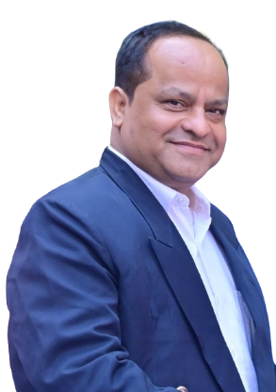

Dr. Meghendra Sharma
Organizing Secretary,
Vigyan Bharati Rajasthan

Embracing Scientific Excellence: A Glimpse into Vigyan Bharati Rajasthan's Journey

Dear Readers,
As we usher in a new year filled with promise and potential, it is with great pleasure that we bring you the latest edition of the Vigyan Bharati Rajasthan quarterly newsletter. In the spirit of scientific inquiry and innovation, our organization continues to be at the forefront of promoting a culture of scientific excellence and knowledge dissemination.

In the dynamic landscape of Rajasthan, Vigyan Bharati has emerged as a beacon of inspiration, fostering a scientific temperament among the youth and encouraging groundbreaking research. Our commitment to advancing science and technology is reflected in the diverse range of activities and initiatives undertaken over the past quarter.

One of the highlights of this quarter was the successful organization of the “India International Science Festival (IISF) – Space Hackathon” at DBT-THISTI & RCB Campus, Faridabad, Haryana from 17-20 January 2024.

Rajasthan Vigyan Mahotsav (National Science Day Celebration 2024) was organized in collaboration with CSIR-Central Electronics Engineering Research Institution (CSIR-CEERI), Pilani; Department of Science and Technology (DST), Rajasthan and CNCER, University of Rajasthan, Jaipur from 26-28 February 2024 at various prominent venues of Jaipur.

As we reflect on the achievements of the past quarter, it is evident that Vigyan Bharati Rajasthan is not merely an organization but a movement that empowers individuals to explore the wonders of science and contribute meaningfully to society. We extend our gratitude to our dedicated members, collaborators, and host institutions for their unwavering support, without which these accomplishments would not have been possible.

Looking ahead, we remain committed to fostering a culture of scientific curiosity, collaboration, and innovation. The journey ahead is filled with exciting possibilities, and with your continued support, Vigyan Bharati Rajasthan will undoubtedly continue to be a catalyst for scientific progress in our state.

Thank you for being a part of our journey.

(Dr. Meghendra Sharma)
Newsletter April–September 2024

Vigyan Bharati Rajasthan

Glimpse of Programs

- 04 April, 2024 – Meeting with DG CSIR - A meeting was organized in the presence of Dr. N. Kalaiselvi (Secretary, Council of Scientific & Industrial Research & Director General CSIR) at CSIR-CEERI, Jaipur Campus. Prominent personalities from various institutions were present in the meeting.
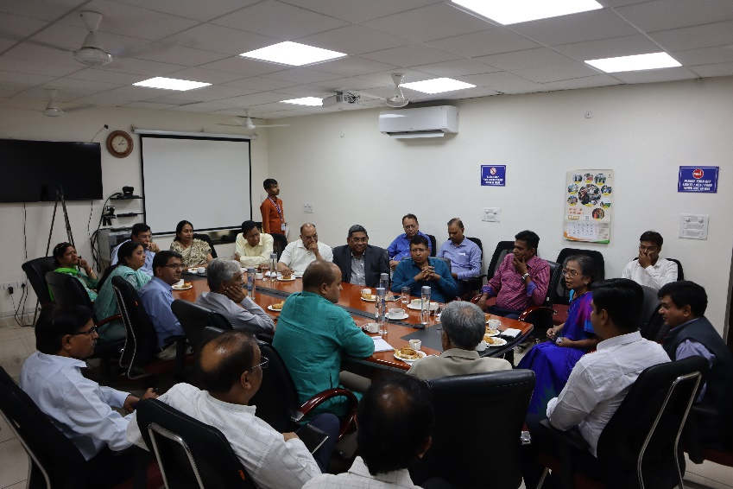
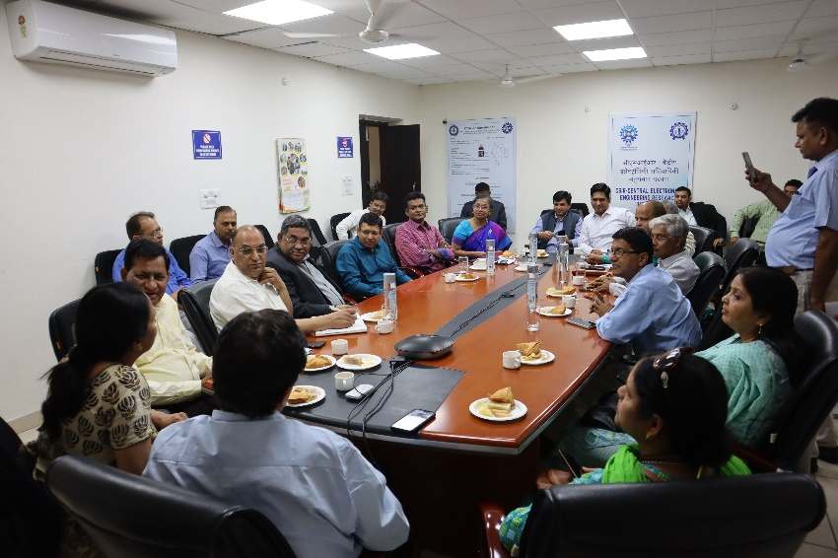
Dr. P.C. Panchariya (Director, CSIR-CEERI, Pilani), Dr. Meghendra Sharma (Secretary, Vigyan Bharati Rajasthan), Shri Vikas Rajpurohit (OSD, Chief Minister Rajasthan), Shri V. Saravana Kumar (Secretary, Department of Science & Technology, Rajasthan), Dr. Shankar Babu (Vice President, Vigyan Bharati Rajasthan), Dr. Ashwani Sharma (Former Director General, NIELIT Meity), Dr. Sanjeev Sharma (Vice Chancellor, National Institute of Ayurveda, Jaipur), Dr. P.C. Trivedi (Former Vice Chancellor, Jai Narayan Vyas University), Dr. J.P. Sharma (Former Vice Chancellor, Mohanlal Sukhadia University, Udaipur), Dr. Vishnu Sharma (Former Vice Chancellor, Rajasthan Veterinary & Animal Sciences University, Bikaner), Shri P.R. Sharma (CEO, Rajasthan Export Promotion Council), Mr. Shailesh Jain (Joint Secretary, Vigyan Bharati Rajasthan), Dr. Raghav Prakash (Director, Parishkar Group), Mr. Anurag Agarwal (Chairman, Arya College of Engineering and IT, Jaipur), Dr. Keshav Badaya (Secretary, St. Wilfred Group), Dr. Ravi Kumar Goyal (COO, NIAM, Jaipur), Dr. Arun Arya (Principal, Arya College), Mr. Kailash Mishra (Assistant Director, Department of Science and Technology), Mr. Rajesh Garg (Assistant Director, Department of Science and Technology), Dr. Rani Saxena (Professor, SKN Agricultural University), Dr. Sanjeeta Sharma (Professor, Rajasthan Veterinary and Animal Sciences University), Dr. Sunita Gupta (Professor, SKN Agricultural University), Mr. Sai Krishna (Scientist-in-Charge, CSIR-CEERI Jaipur Campus), Dr. Sachin Devassy (Principal Scientist), Dr. Navjot Kumar (Senior Scientist), Dr. Vijay Chatterjee (Senior Scientist) were prominently present. Vigyan Bharti Rajasthan requested the heads of various institutions present to prepare a concept note on the role of CSIR as per the requirement of their institution so that the state can move forward rapidly in the field of science, technology and research with the cooperation of CSIR and Department of Science and Technology. All the people from various institutions discussed the role of CSIR in improving their institutions in science, technology and research. Dr. PC Panchariya presented the proposal of setting up CSIR Resource Center in Jaipur to the Director General. The Director General listened to everyone's suggestions carefully and assured all possible help from CSIR.
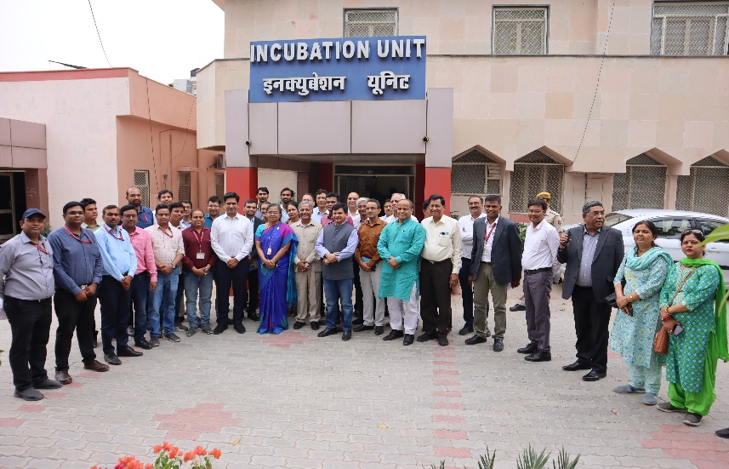
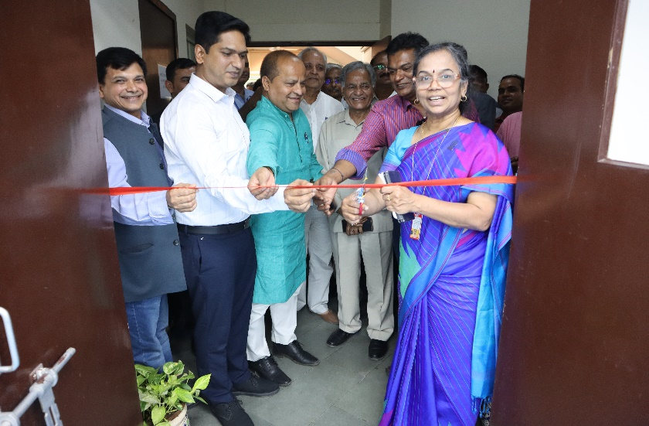

Vigyan Bharati Rajasthan

Newsletter April–September 2024

- 07 April, 2024 – World Health Day - On the occasion of World Health Day, Vigyan Bharti Rajasthan, Sikar Vibhag & Mental Health Welfare and Awareness Trust organized a group yoga and seminar in Smriti Van Sikar. The main speakers in the program were Dr. Meghendra Sharma, Secretary Vibha Rajasthan, Dr. O P Sharma, Joint Director, Medical and Health Department, Rajasthan Government, Dr. Ramavtar Yadav, Professor & HOD, Surgical Department, SS Medical College, Sikar, Psychiatrist Dr. Manish Meel, Yogacharya Mahavir Ji. The program was concluded in the presence of the team of Vibha Sikar Vibhag and dignitaries.
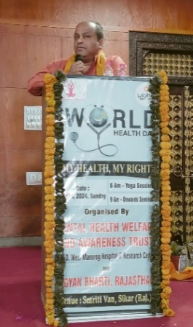
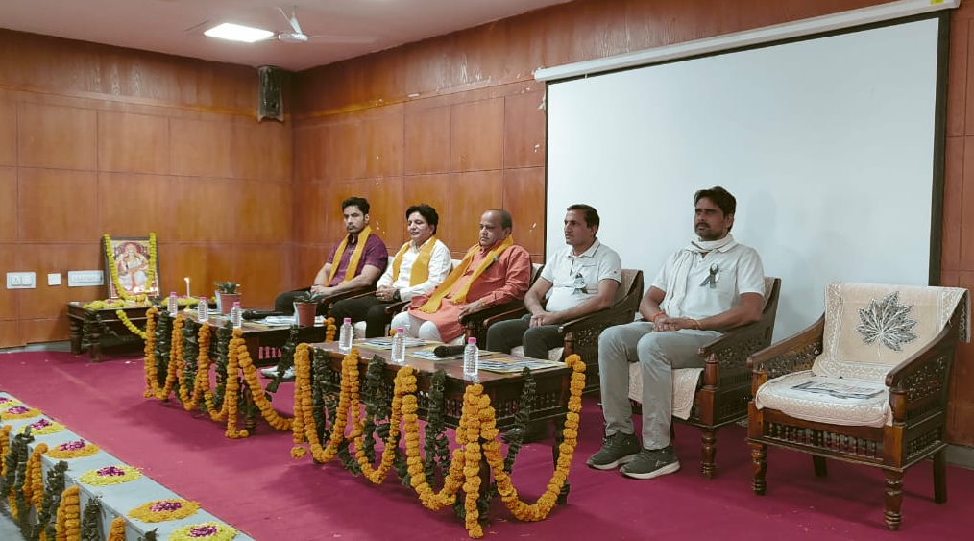

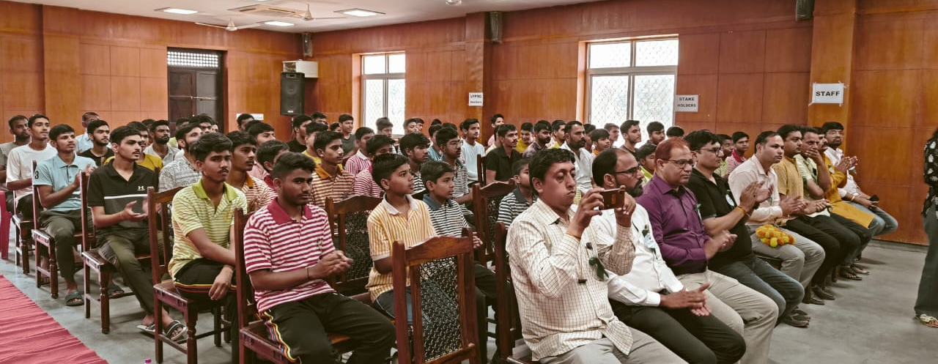

- 09 May, 2024 Vigyan Sanskar Shivir - The three-day “Vigyan Sanskar Shivir” was organized at the S.S. Jain Subodh P.G. (Autonomous) College from 9-11 May 2024. The inaugural ceremony of the program started at 09:00 AM sharp. Dr. Abhay Jere (Vice Chairman, AICTE, Government of India) was the chief guest & keynote speaker for the first day of the program. The program was presided over by Dr. Laxman Singh Rathore, (President, Vigyan Bharti Rajasthan), Sh. V. Saravana Kumar (Secretary, DST Rajasthan) and Er. Anurag Agarwal (Chairman, ACEIT) was present as Special guests. Program coordinator Dr. Meghendra Sharma (Secretary, Vigyan Bharti, Rajasthan) introduced the Vigyan Sanskar Shivir and its structure. He said hands on workshops, exhibitions, popular lectures, skill development training, yoga session and interaction with scientists are included in this three-day Vigyan Sanskar Shivir which will take place from 8:30 AM to 1:00 PM during these three days. Prof. K.B. Sharma (Principal, S.S. Jain Subodh P.G. College) welcomed the dignitaries and participants to the program. This three-day Vigyan Sanskar Shivir was organized by Vigyan Bharti Rajasthan in collaboration with DST Rajasthan, CSIR-CEERI Pilani, RTU Kota, BTU Bikaner and S.S. Jain Subodh P.G. (Autonomous) College, Jaipur.
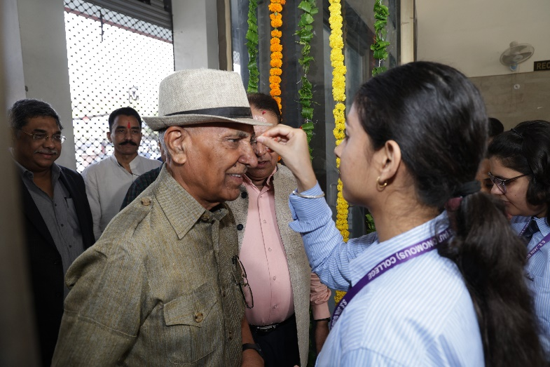
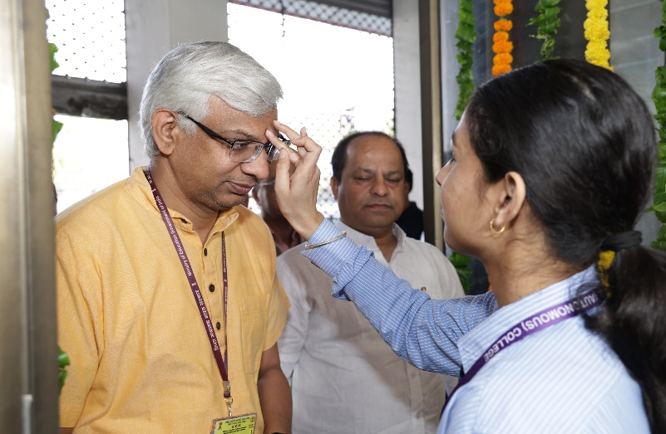
Vigyan Bharati Rajasthan

Newsletter April–September 2024

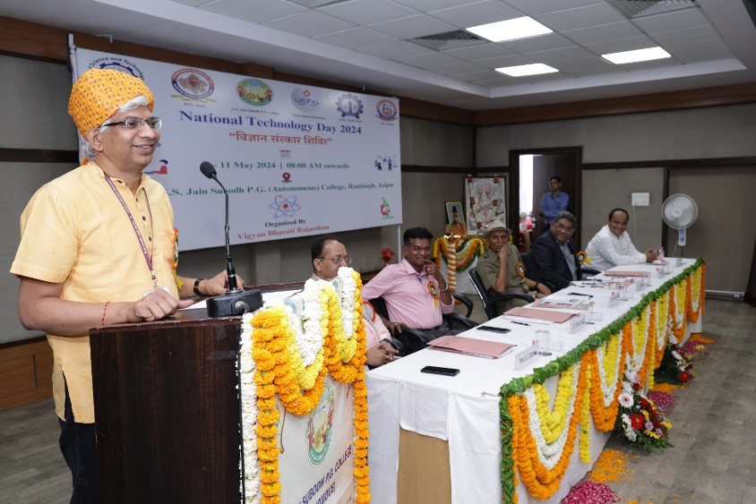
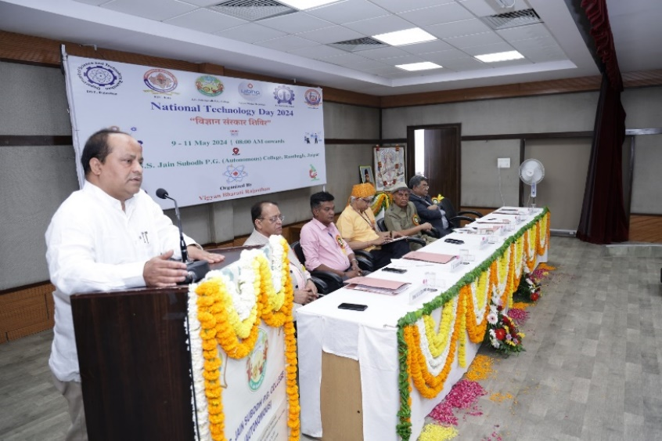
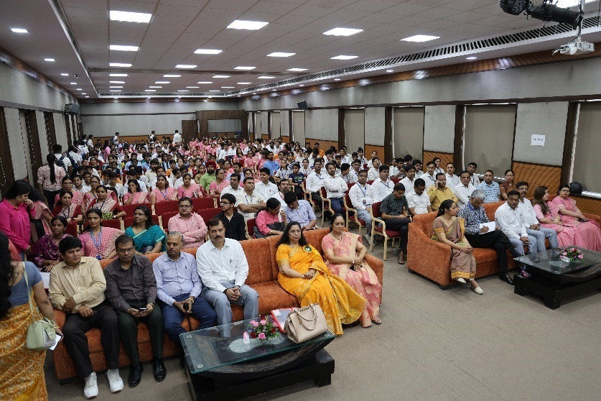
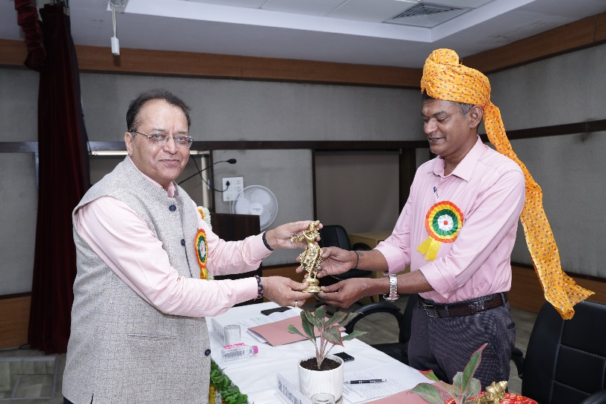
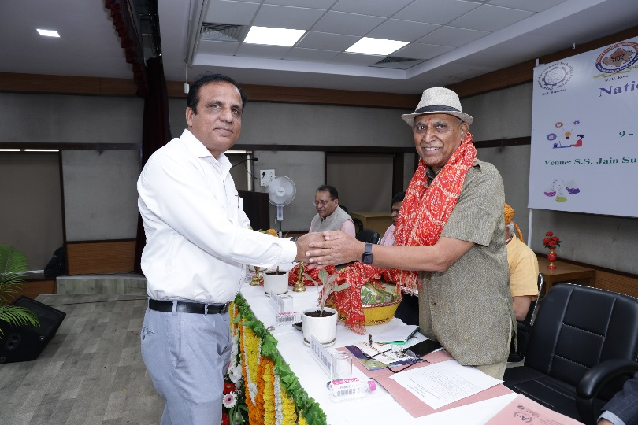
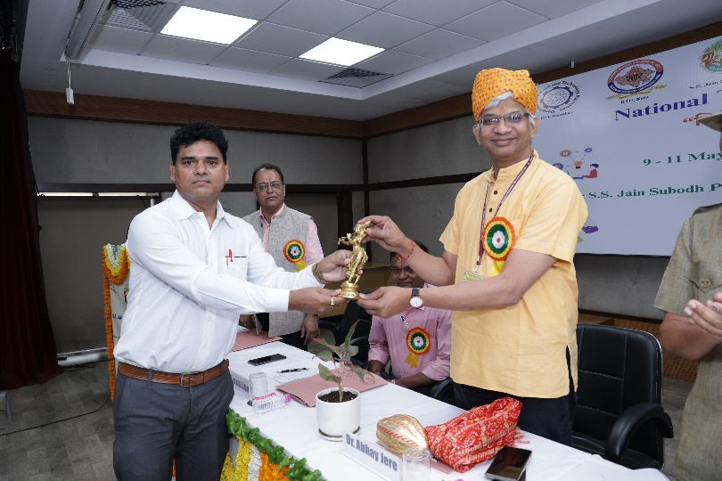
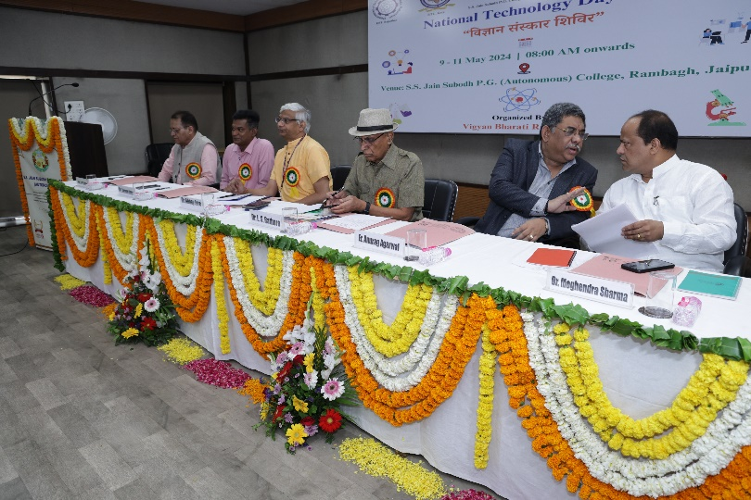
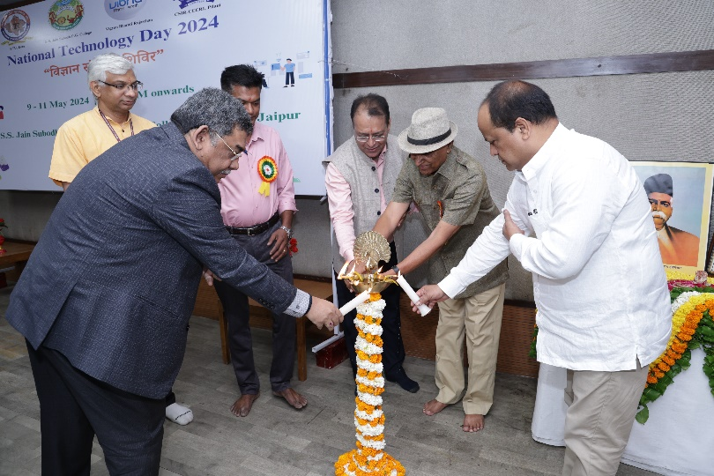
Newsletter April–September 2024

Vigyan Bharati Rajasthan

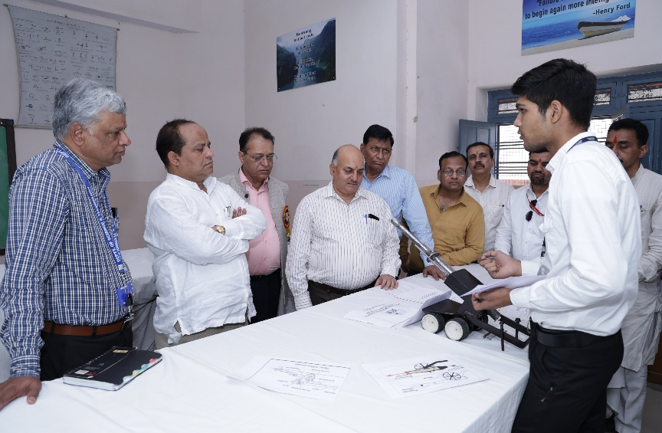
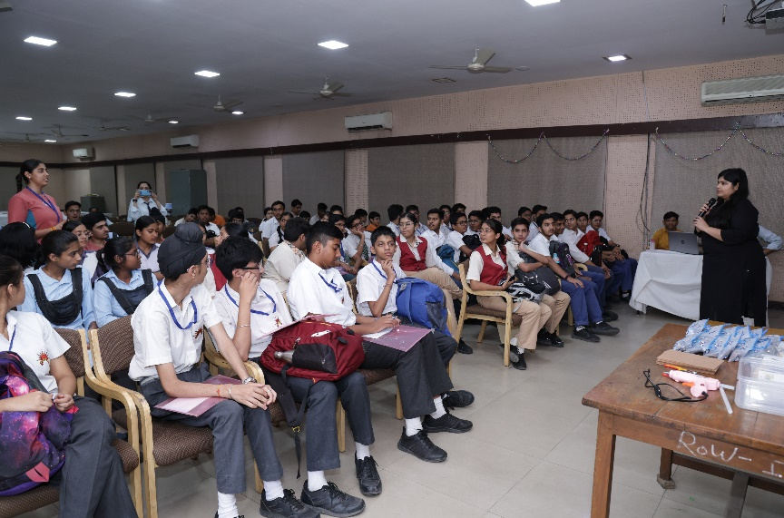
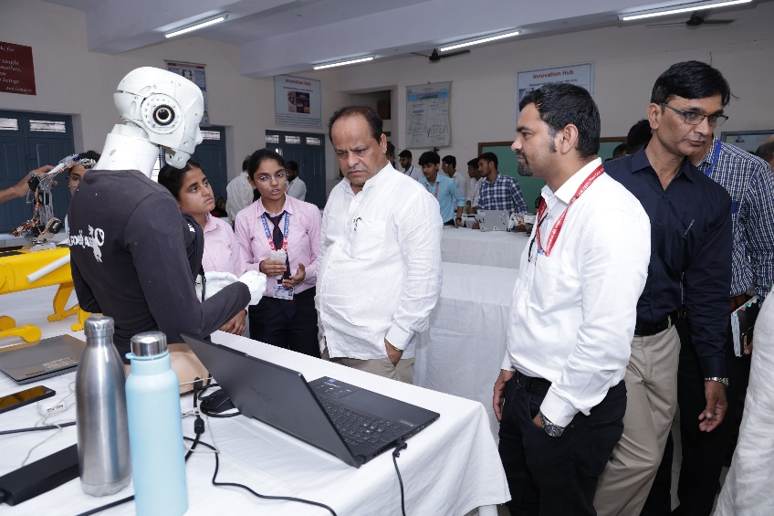
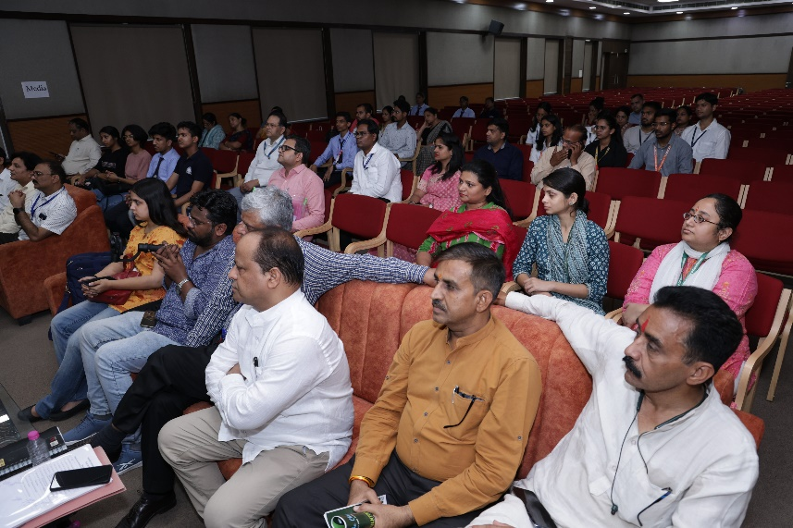
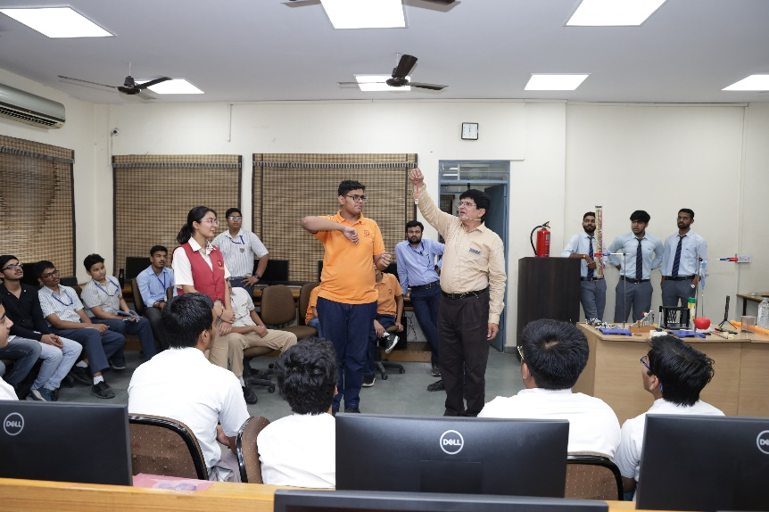
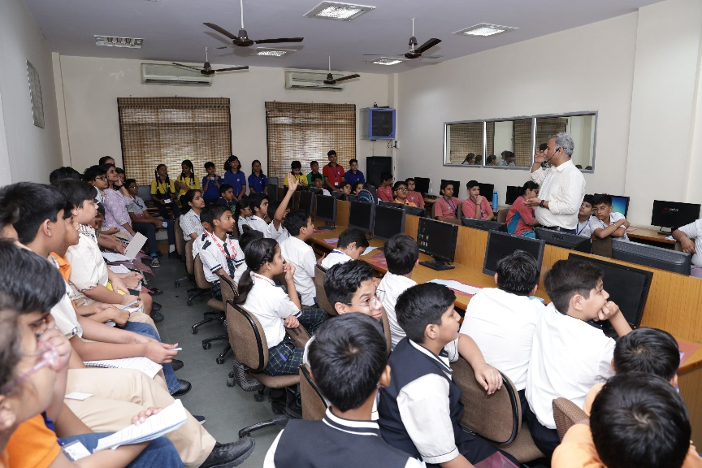
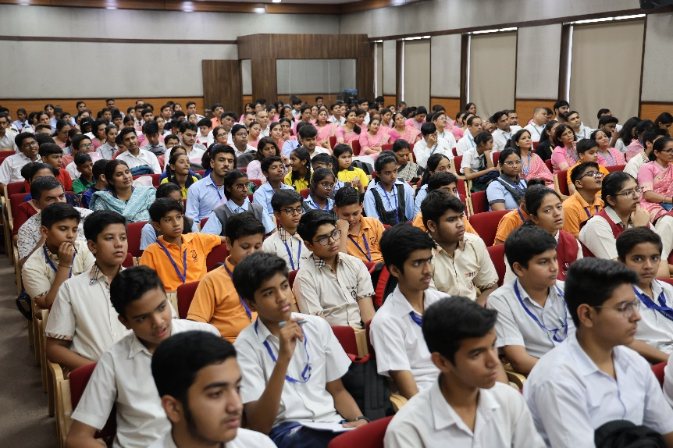
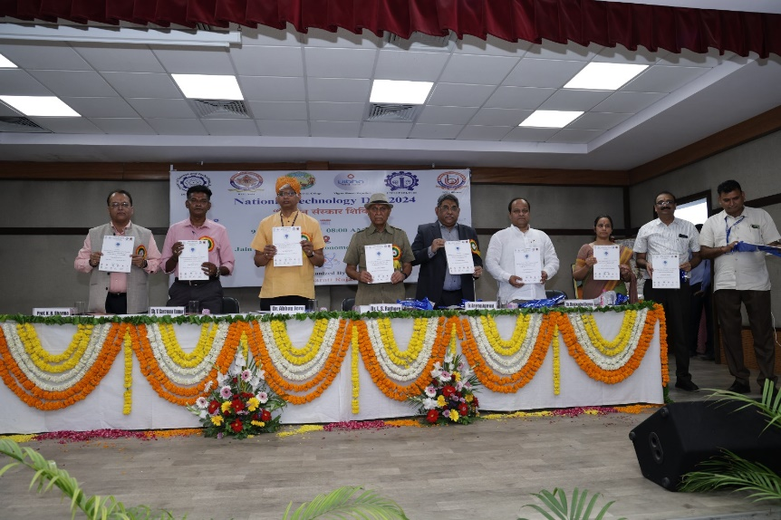
Newsletter April–September 2024

Vigyan Bharati Rajasthan

- 10 May, 2024 Vigyan Sanskar Shivir: The second day of the three-day Vigyan Sanskar Shivir started with the inaugural session at the seminar hall at the S.S. Jain Subodh P.G. (Autonomous) College. Dr. Akhilesh Mishra (Scientist F, Department of Science and Technology, Government of India) was the chief guest and keynote speaker for the second day of the program. Dr. Mishra said that many innovations have taken place in the field of science and technology, as a result of which employment opportunities for the youth have increased in the country. Mr. P.R. Sharma (CEO, REPC, Government of Rajasthan), Mrs. Lata Rawat (Mentor, Cambridge Court Group), Dr. Arvind Agarwal (Chairperson, Arya College of Engineering) were present as the special guests on the second day.
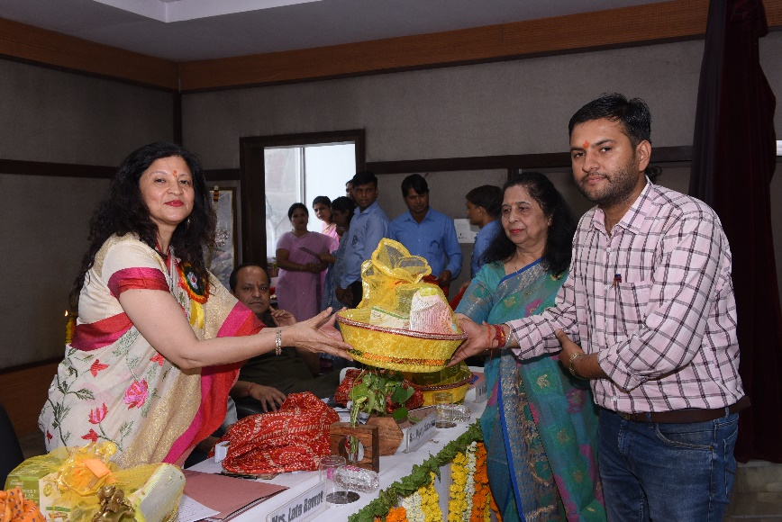
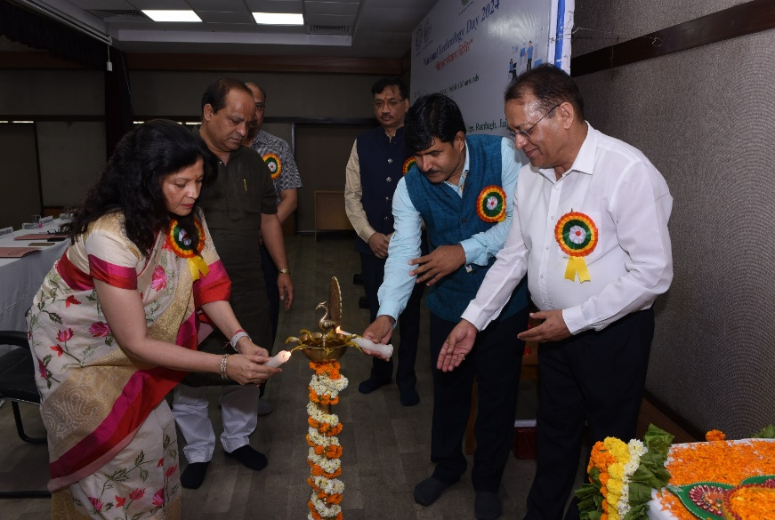
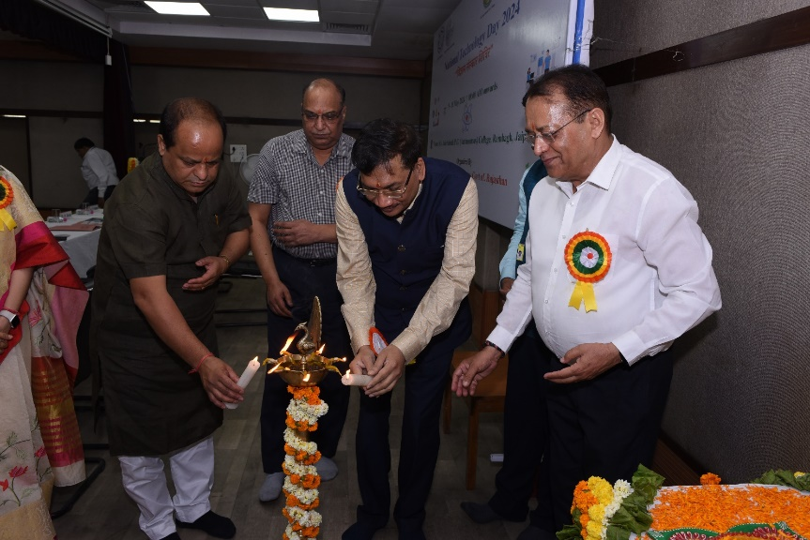
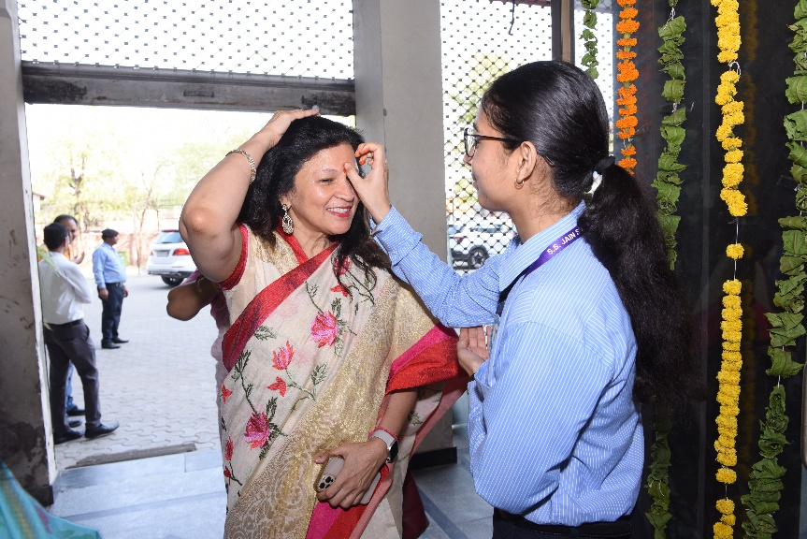
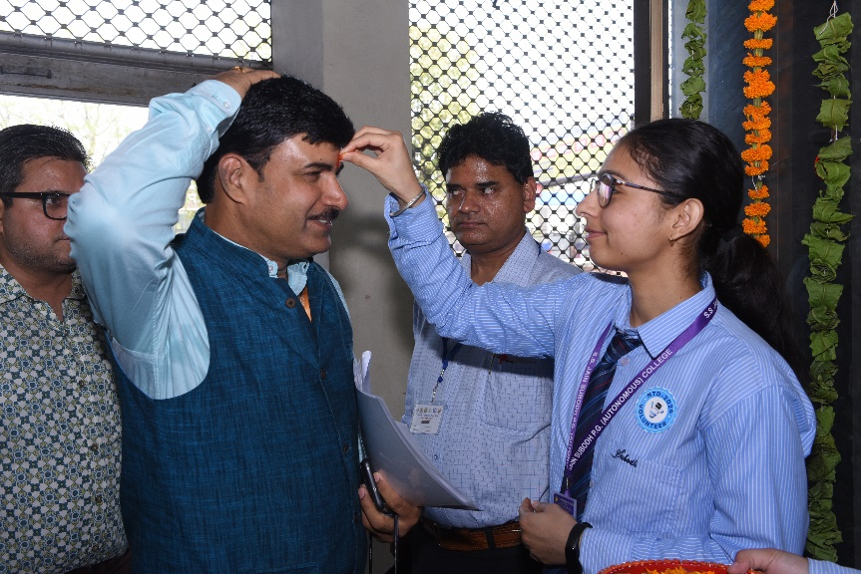
Prof. K.B. Sharma (Principal, S.S. Jain subodh P.G. College) delivered the welcome speech. Dr. Meghendra Sharma (Secretary, Vigyan Bharti Rajasthan) introduced the guests to the three-day “Vigyan Sanskar Shivir”.
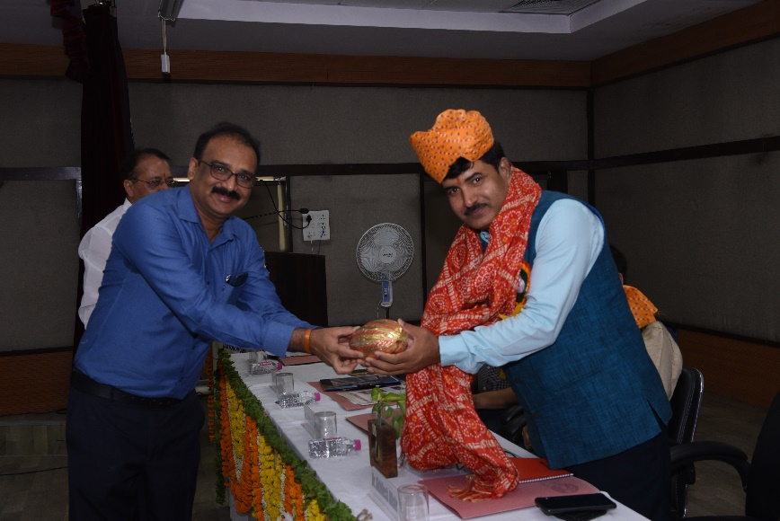
Vigyan Bharati Rajasthan

Newsletter April–September 2024

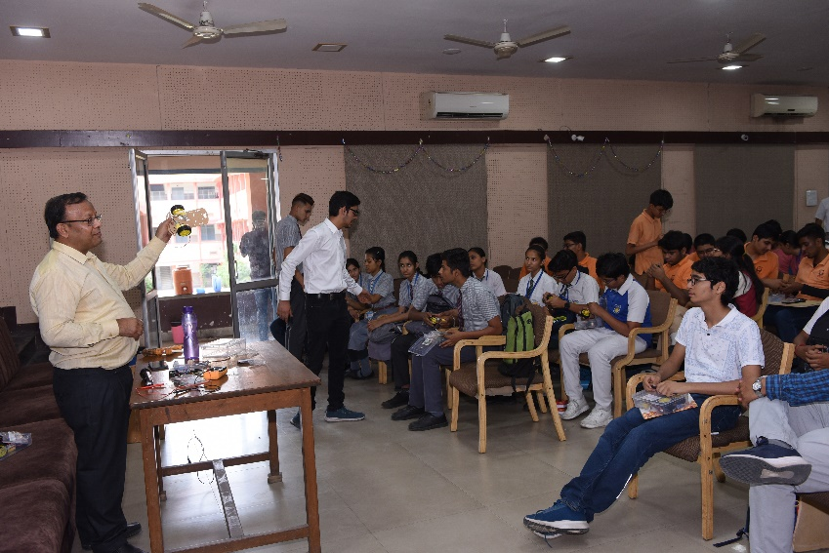
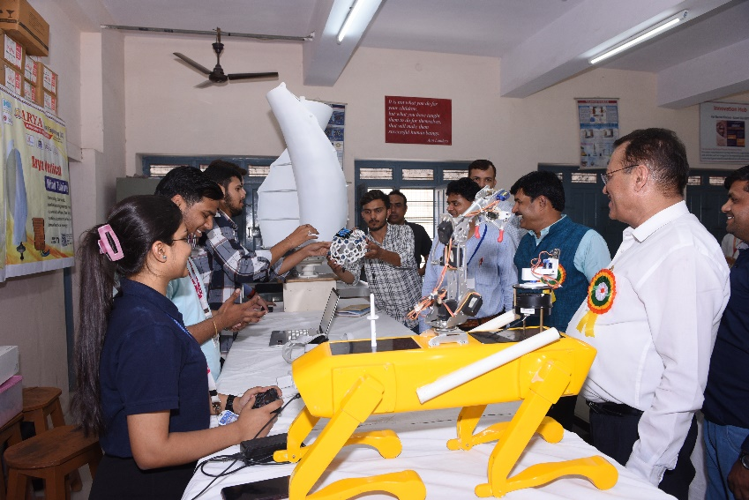
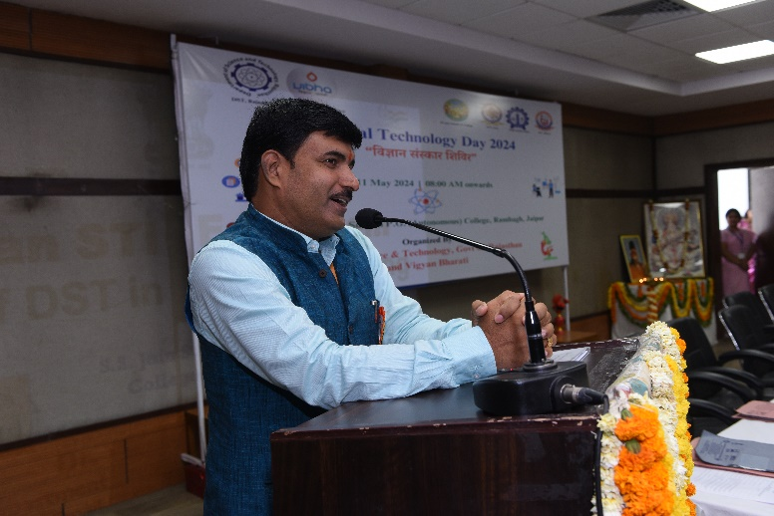
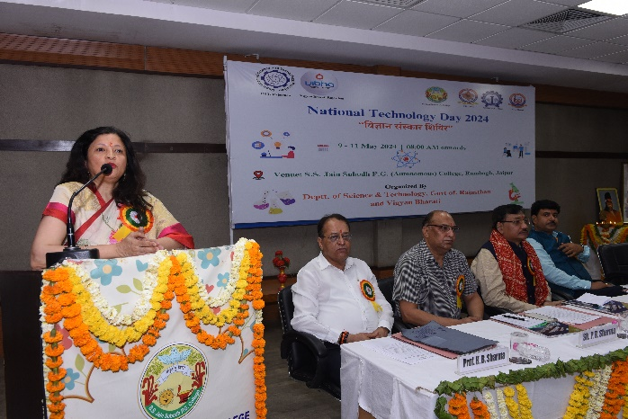
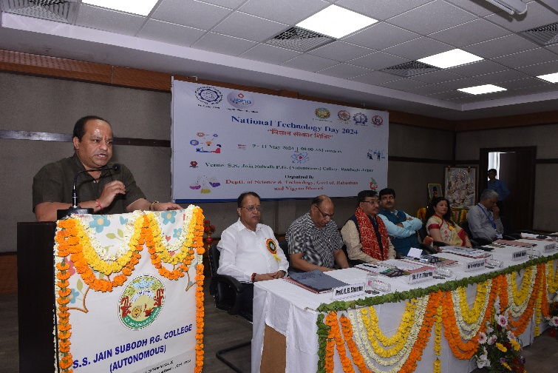
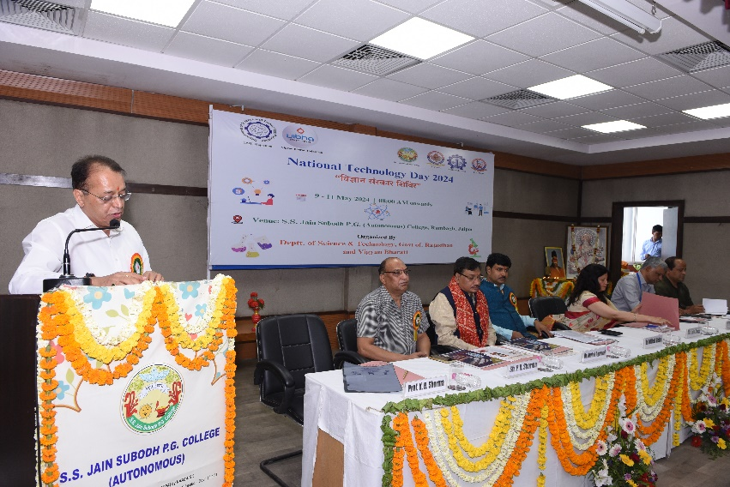
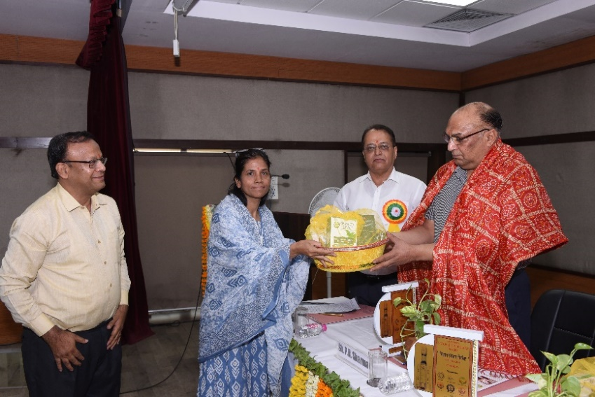
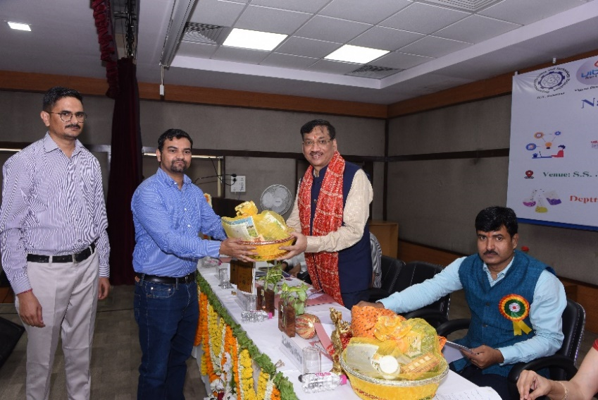
Newsletter April–June 2024

Vigyan Bharati Rajasthan

- 11 May 2024 National Technology Day: The program concluded on the third and last day of the Vigyan Sanskar Shivir at the S.S. Jain Subodh P.G. (Autonomous) College. Dr. Manoj Rohilla (Scientist F, Department of Biotechnology, Government of India) was the chief guest and keynote speaker and Shri Vivekananda Pai (National Secretary, Vigyan Bharti) was the Guest of Honor for the last day. The program was presided over by Prof. S.K. Singh (Vice Chancellor, Rajasthan Technical University, Kota). Dr. L.S. Rathore (President, Vigyan Bharti Rajasthan), Shri V. Saravana Kumar (Secretary, Department of Science and Technology, Rajasthan), Shri Biju George Joseph (Police Commissioner, Jaipur) and Shri Sumer Singh Bothra (Hon. Secretary, Subodh Shiksha Samiti) were present as the Special Guests.

The program started with the inaugural session, Prof. K.B. Sharma (Principal, S.S. Jain Subodh P.G. (Autonomous) College) delivered the welcome address and Dr. Meghendra Sharma (Secretary, Vigyan Bharti Rajasthan) presented a brief report of the various activities held during the three-day program. About 350 students from various schools and engineering colleges participated in the workshop, hands on training and exhibition for three days. About 85 students from junior group (class 6th to 8th) and 97 students from senior group (class 9th to 12th) and about 155 students from engineering group.

Eleven renowned personalities were conferred with Late Shri Jayant Sahasrabuddhe Award of Excellence for their immense contribution and work in their respective fields. Prof. Vishnu Sharma (Former Vice Chancellor, RAJUVAS, Bikaner), Prof. Sanjeev Sharma (Vice Chancellor, NIA, Jaipur) Smt. Priti Chandra (Additional Commissioner of Police, Traffic & Admin, Jaipur), Dr. Girdhar Goyal (Additional Superintendent, SMS Hospital, Jaipur), Sh. Ajitabh Sharma IAS (Principal Secretary to Govt. Dept. of Industries & MSME), Sh. I.C. Agarwal (Chairman, Kailash Group), Dr. B. Lal Gupta (Director, BIBT, Jaipur), Er. Anurag Agarwal (Chairman, ACEIT, Jaipur), Dr. Atul Gupta (Chairman, Sunrise Organic) Sh. Vivek Ladha (Diamond Exporter, Jaipur) were among the felicitated dignitaries. Awards were given to the winners from all three-student category (Junior, Senior, engineering) and medals to all the participants to boost their confidence and appreciate their efforts in the valedictory ceremony. Program coordinator Dr. Balram Tripathi delivered the vote of thanks and thanked all the dignitaries for their valuable time and glorified presence.
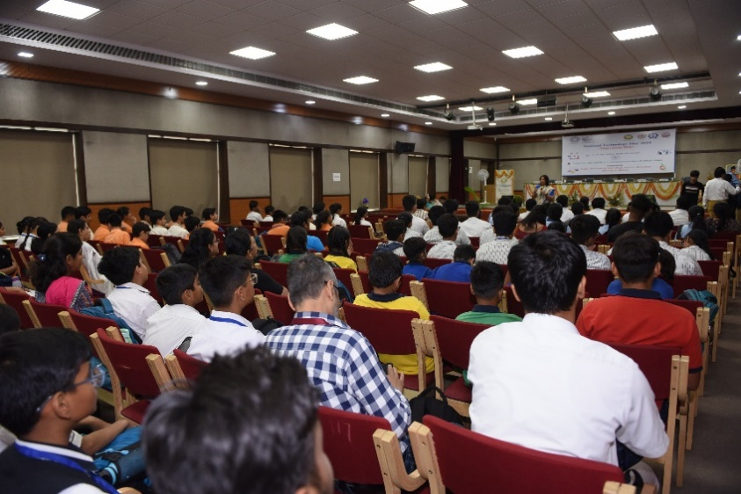
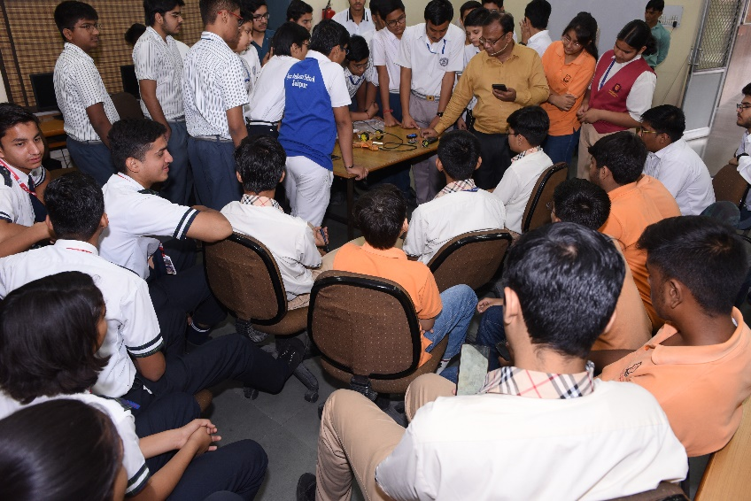

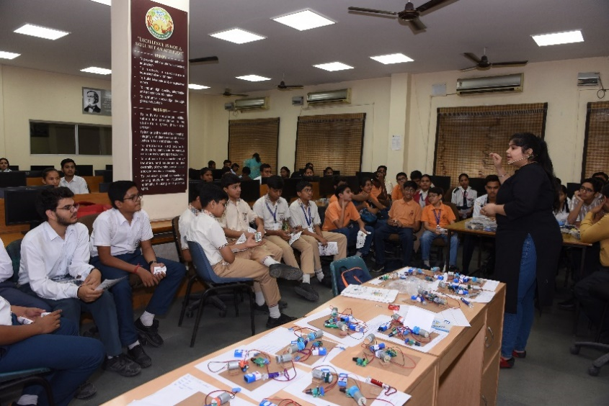
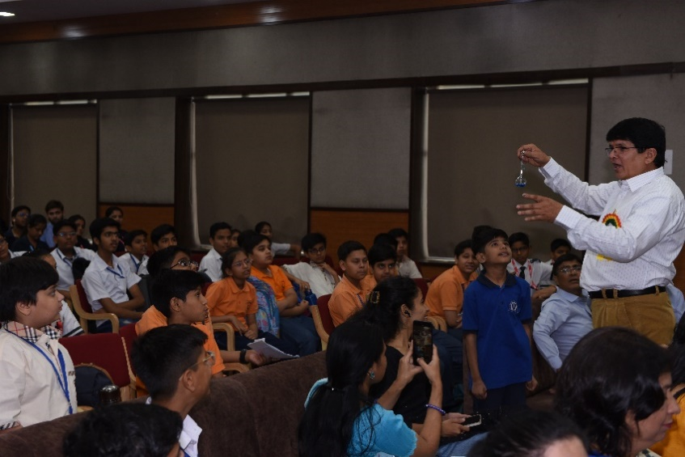

Newsletter April–September 2024

Vigyan Bharati Rajasthan

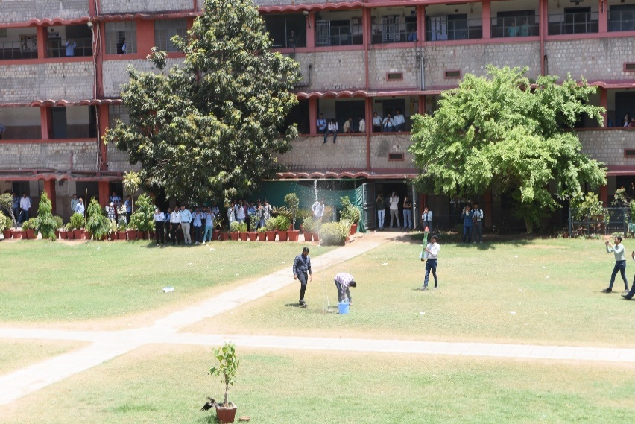
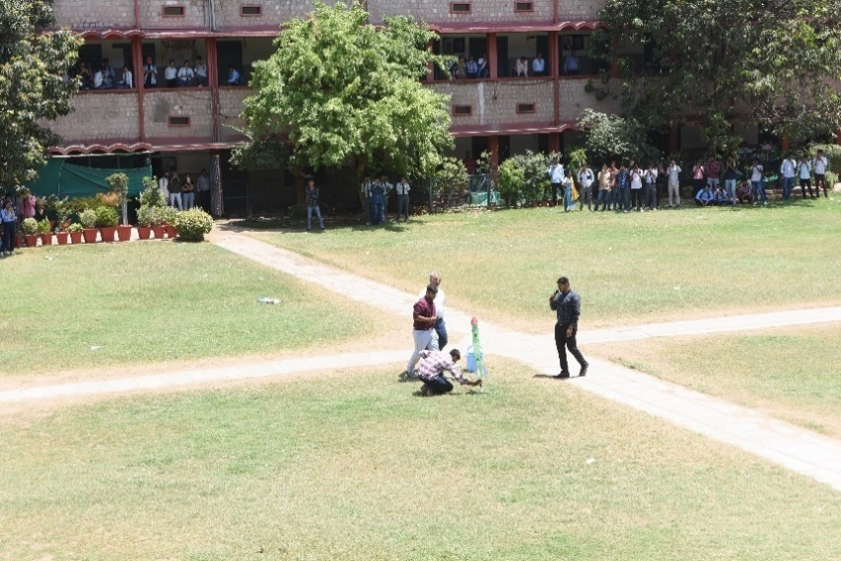
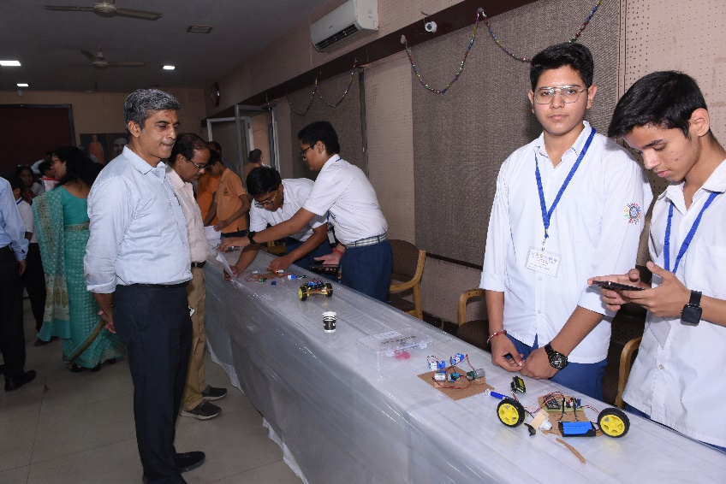
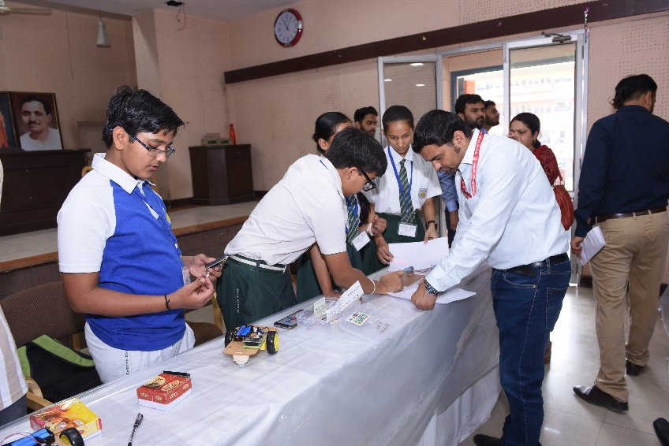
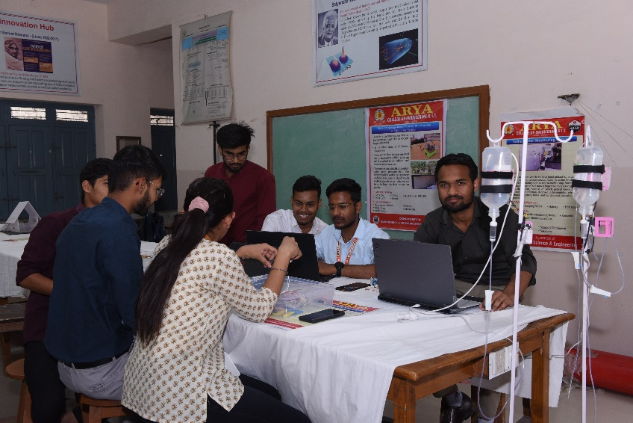
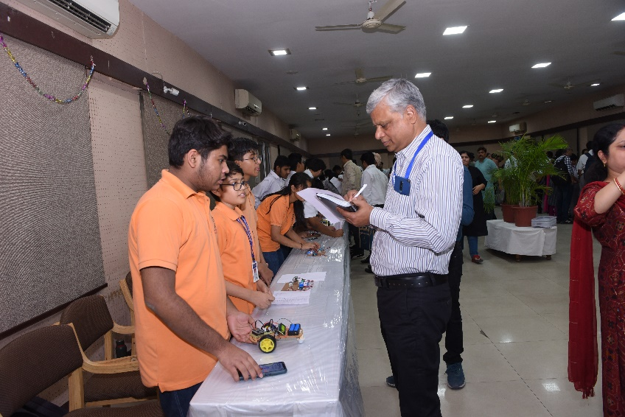

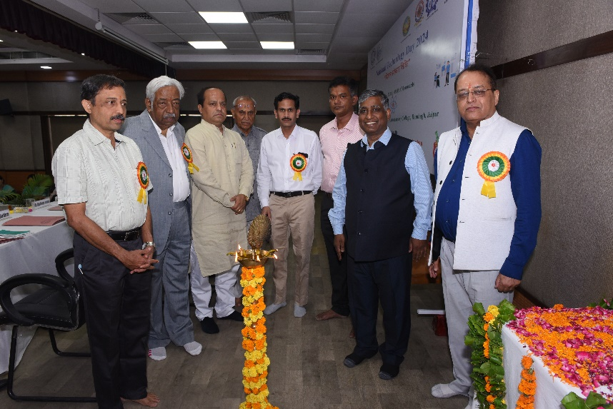
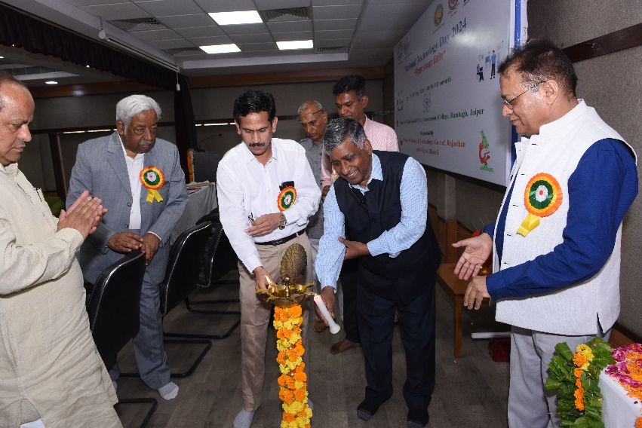

Vigyan Bharati Rajasthan

Newsletter April–September 2024

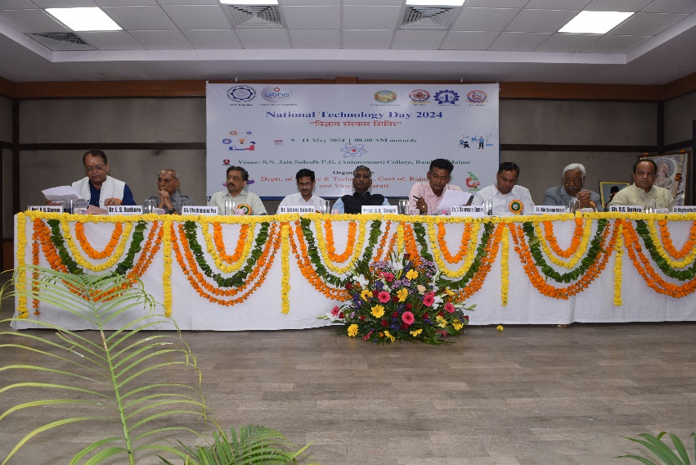

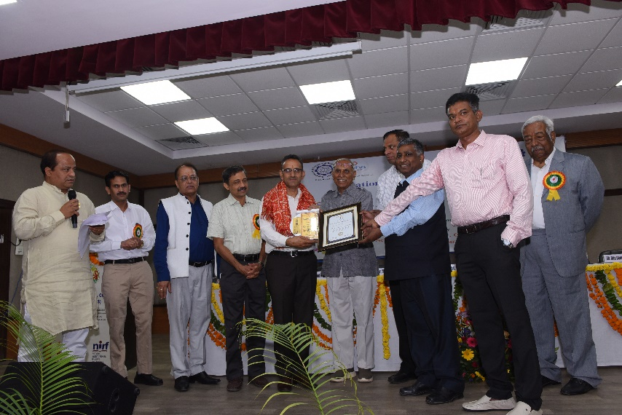
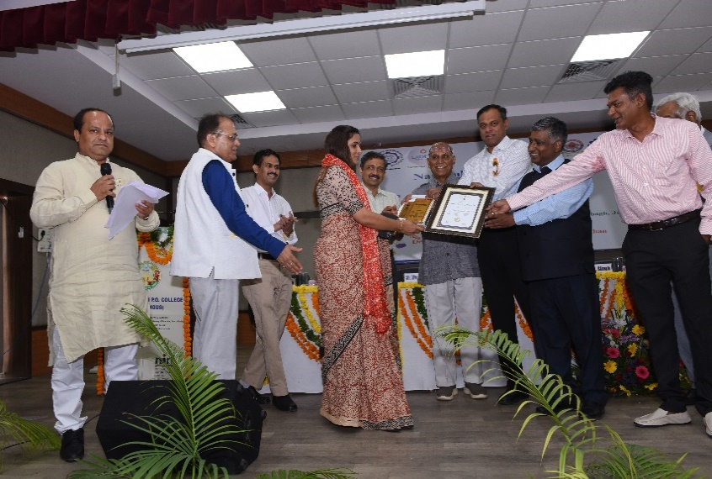
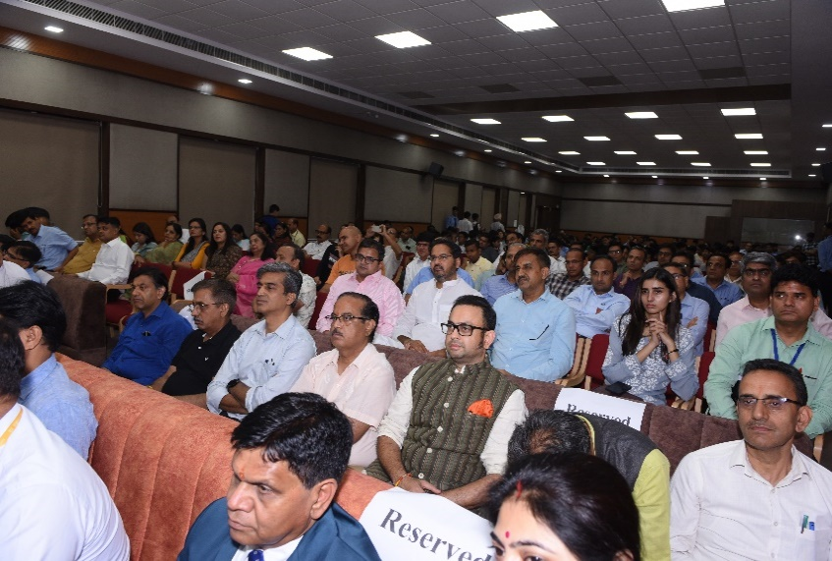
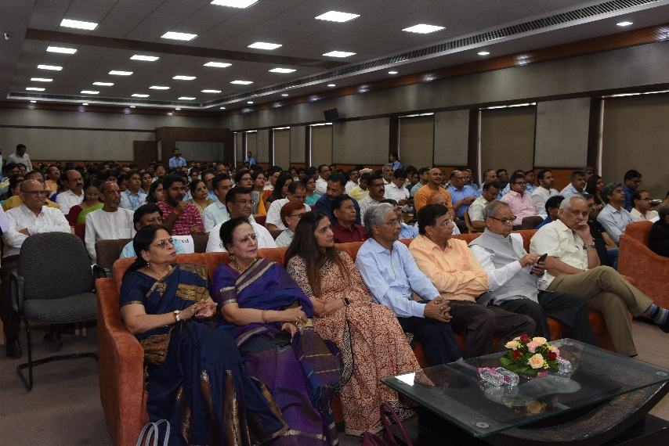

Vigyan Bharati Rajasthan

Newsletter April–September 2024

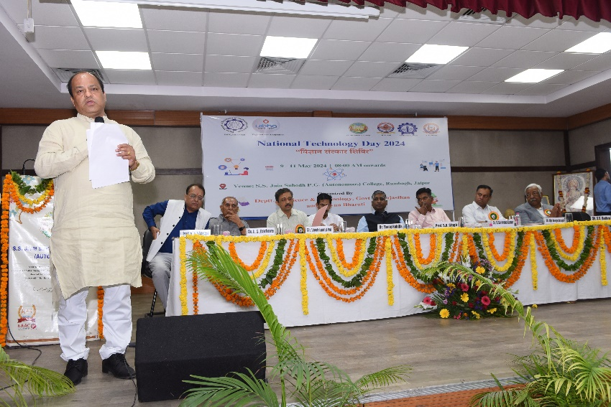
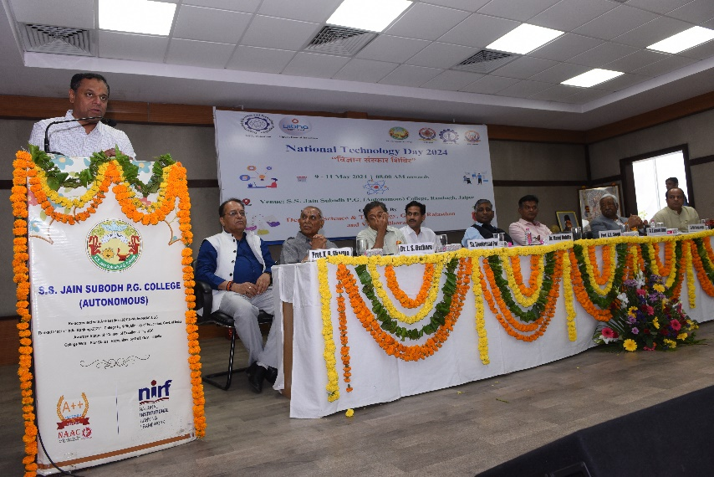
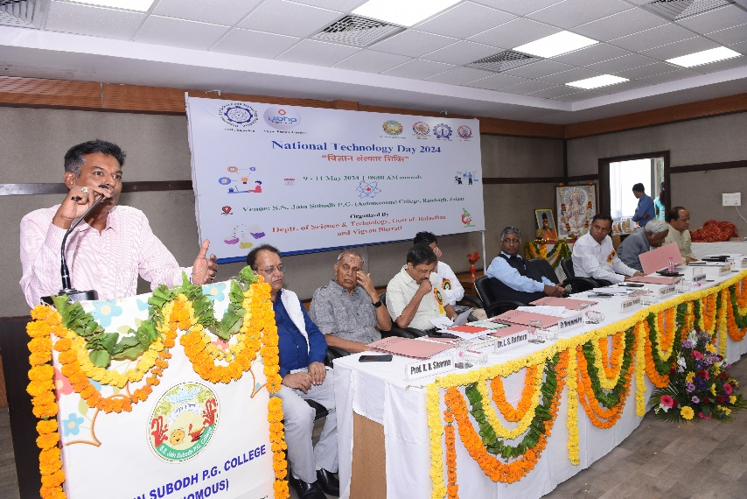
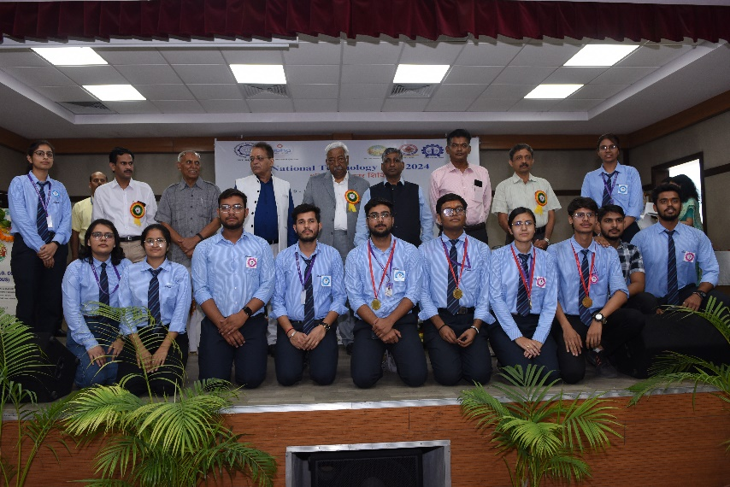
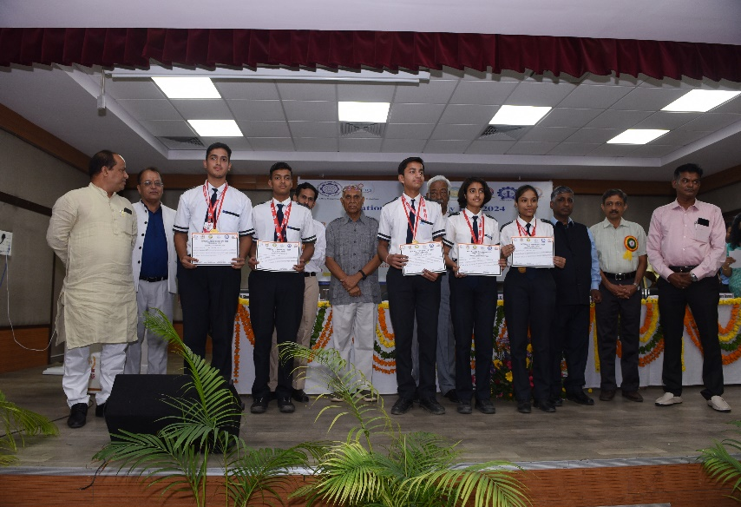
Vigyan Bharati Rajasthan

Newsletter April–September 2024

- 5, June 2024 - World Environment Day program was organized by Vigyan Bharti Rajasthan on 05 June, 2024 at Parishkar College of Global Excellence (Autonomous) Jaipur. In the first phase of the program, about 250 participants participated in the Cyclothon Rally under the leadership of Dr. GL Sharma, Dr. Lokendra Sharma and Shri KC Meena IFS. The Cyclothon started from Parishkar College after the flag off by Dr. Meghendra Sharma (Secretary, Vigyan Bharti Rajasthan) and Dr. Raghava Prakash (Director, Parishkar College). The Cyclothon passed through various routes of Mansarovar spreading a message of environmental protection and awareness and concluded again at Parishkar College. The participants were felicitated by Shri V. Saravana Kumar (Secretary to the Government, Department of Science and Technology, Rajasthan) Dr. Meghendra Sharma, Dr. Raghav Prakash, Dr. Savita Paiwal (Principal, Parishkar College) by medals.

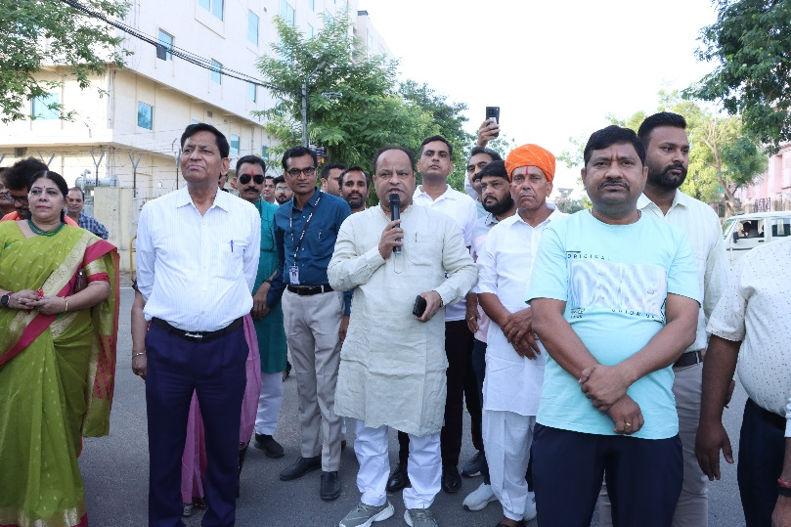
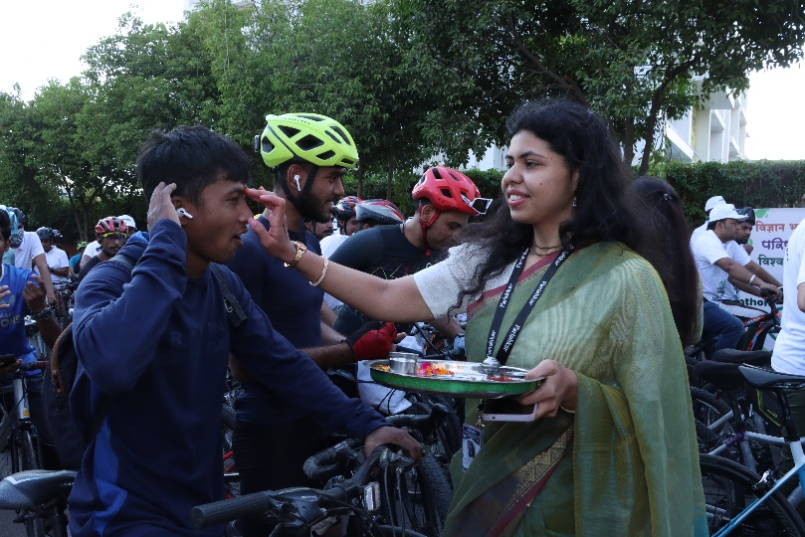
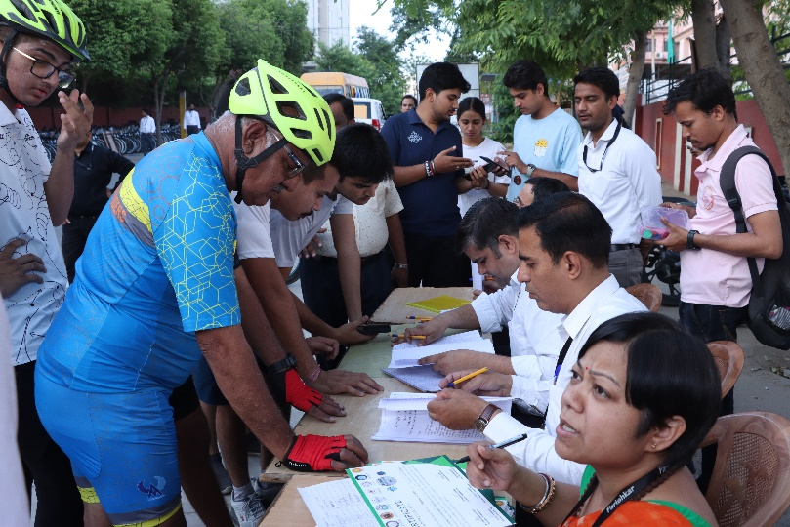
Thereafter, the formal program started with the Vraksh pooja and arti by the guests present on the dais. Dr. Meghendra Sharma administered the oath of environmental protection to all the dignitaries and the audience presented in the dome. Dr. Raghav Prakash welcomed all the guests on the dais - Shri Prakash Das Ji Maharaj, Prof. S.K. Singh (Vice Chancellor, Rajasthan Technical University, Kota), Prof. Balraj Singh (Vice Chancellor, Shri Karna Narendra Agricultural University, Jobner), Prof. Nishtha Jaswal (Vice Chancellor, Dr. B.R. Ambedkar Law University, Jaipur), Shri V. Saravana Kumar (Secretary to Government, Department of Science and Technology, Rajasthan), Dr. P.C. Panchariya (Director, CSIR-CEERI, Pilani), Dr. Ashok Sharma (Prant Sanyojak, Paryavaran Gatividhi) and Dr. Meghendra Sharma (Secretary, Vigyan Bharti Rajasthan) by presenting them saplings, mementoes and shawls. In his welcome address, Dr. Raghav Prakash welcomed all the dignitaries and explained the importance of nature and gave details of the academic achievements of the college and called upon the dignitaries and participants present to take VIBHA Plantation Drive forward.
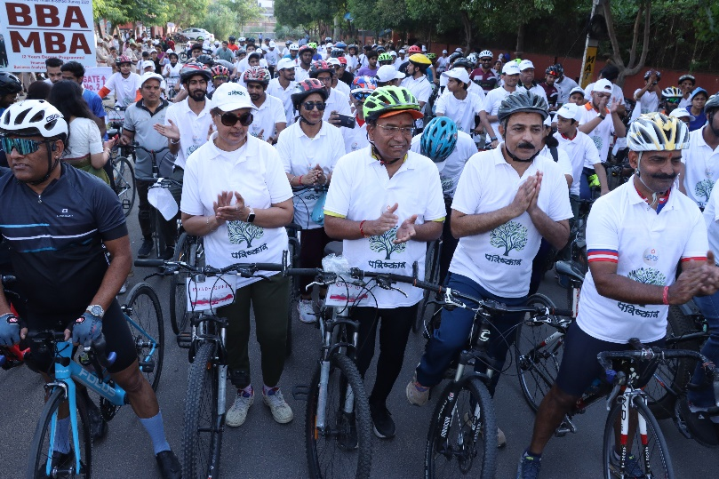
After this, Dr. Meghendra Sharma gave detailed information about the various programs and activities being conducted by Vigyan Bharti in Rajasthan and introduced VIBHA Plantation Drive. Dr. Sharma informed that in this plantation drive, about 27 different government and non-government departments like Forest Department Rajasthan, Agriculture and Horticulture Department Rajasthan, Police Commissionerate Jaipur, Rajasthan State Pollution Control Board, Rajasthan State Biodiversity Board, Meteorological Department Centre Jaipur, Jaipur Municipal Corporation, Rajasthan Health Science University Jaipur, National Ayurveda Institute Jaipur, Hahnemann Charitable Mission Society, S.S. Jain Subodh PG College Jaipur, Priyanka Heart and Cardiac Centre Jaipur, Arya College of Engineering and IT, Dharma Jagran Manch and Arya College of Engineering are associated as supporting organizations, which will play an important role in making the
Newsletter April–September 2024

Vigyan Bharati Rajasthan

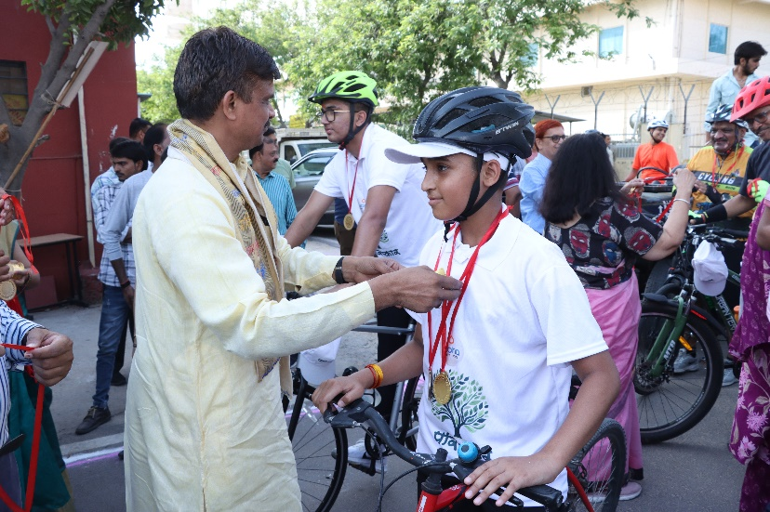
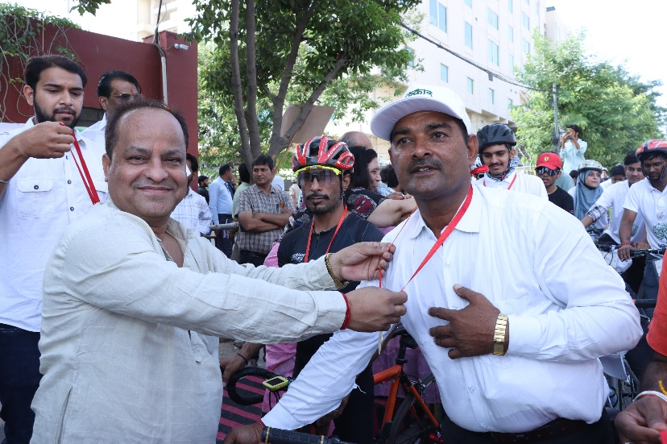

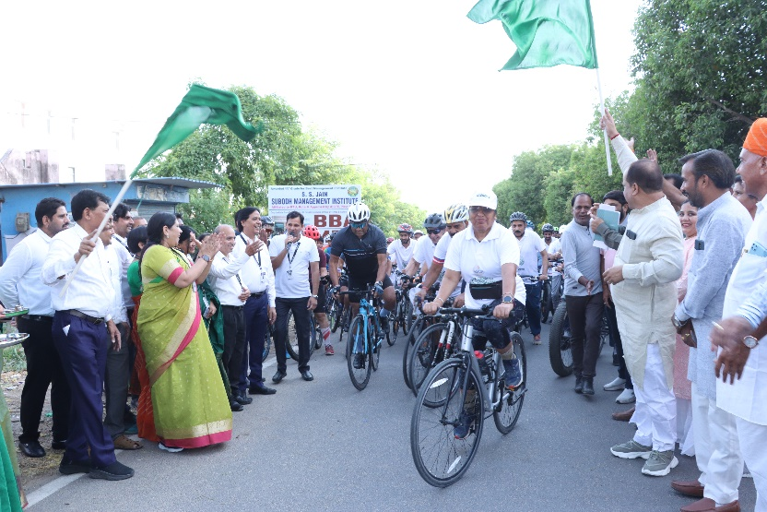
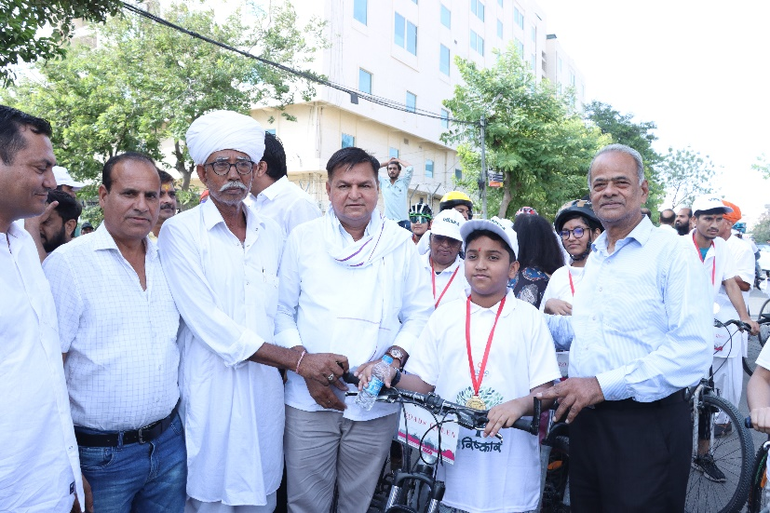
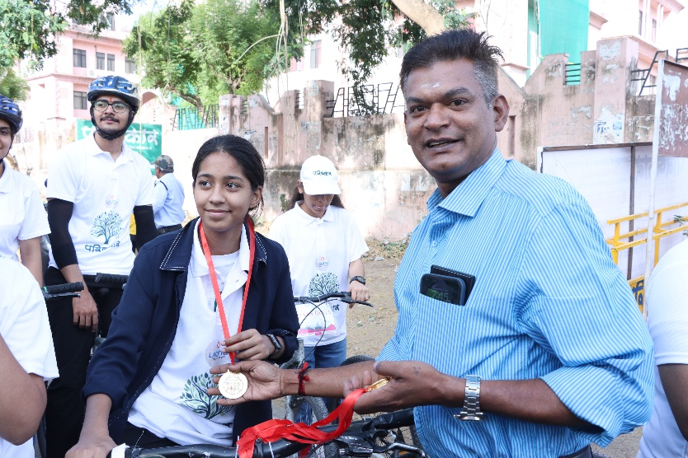
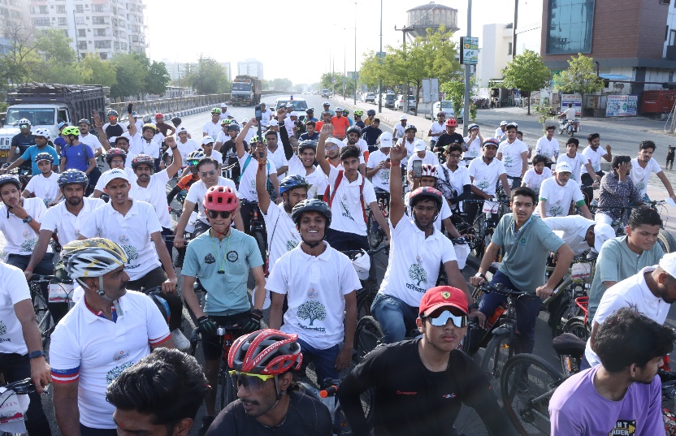
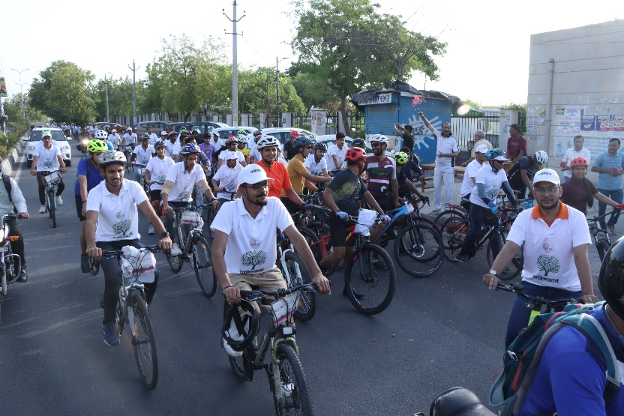
VIBHA Plantation Drive successful and fulfilling the goal of this plantation drive by planting one crore trees/plants in the entire Rajasthan in the coming one year. VIBHA Plantation Drive portal was also launched to get connected with the plantation drive by which one can upload the details and a photo with the tree planted by him/her.
Vigyan Bharati Rajasthan

Newsletter April–September 2024

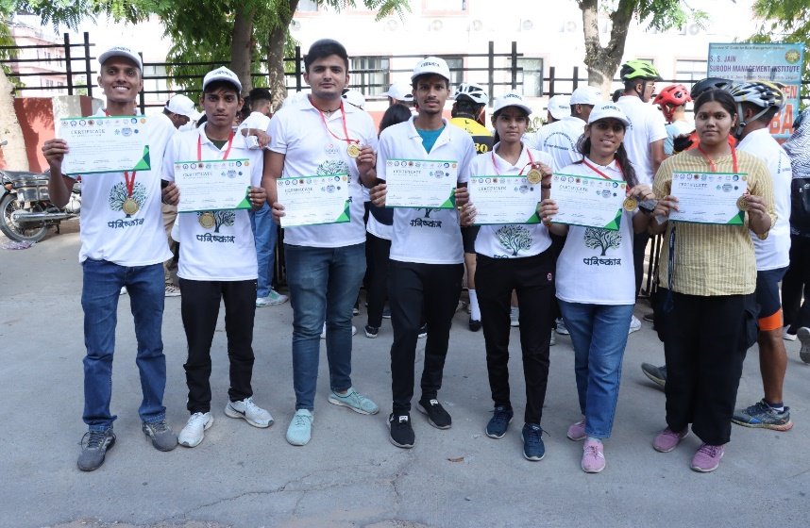
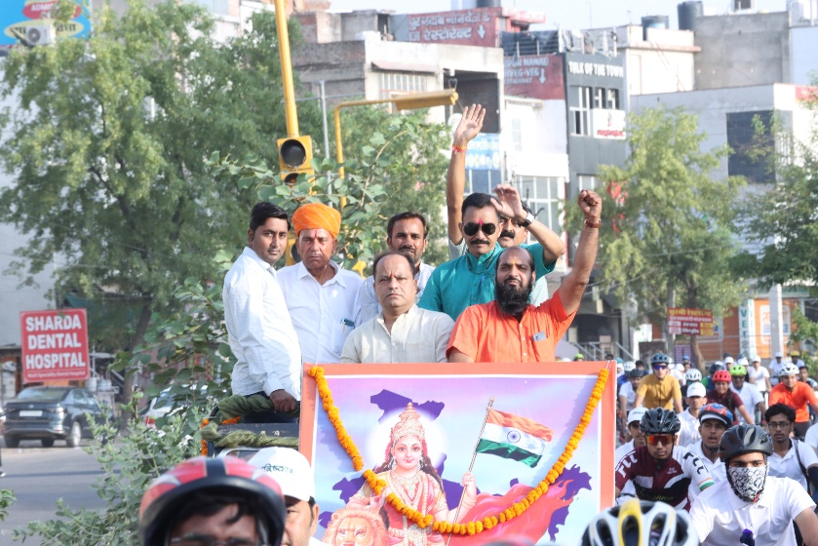
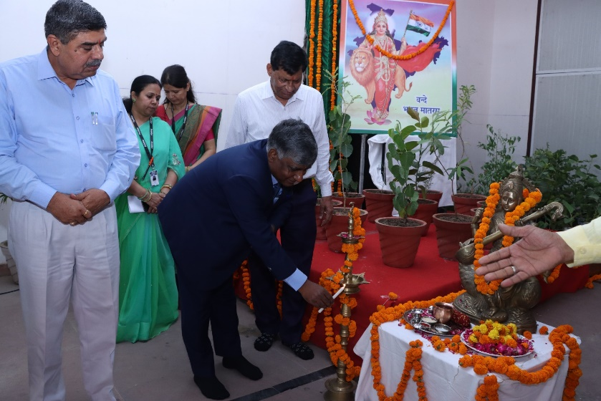
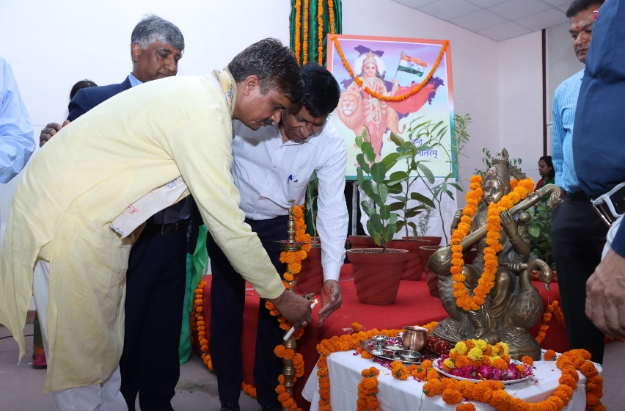
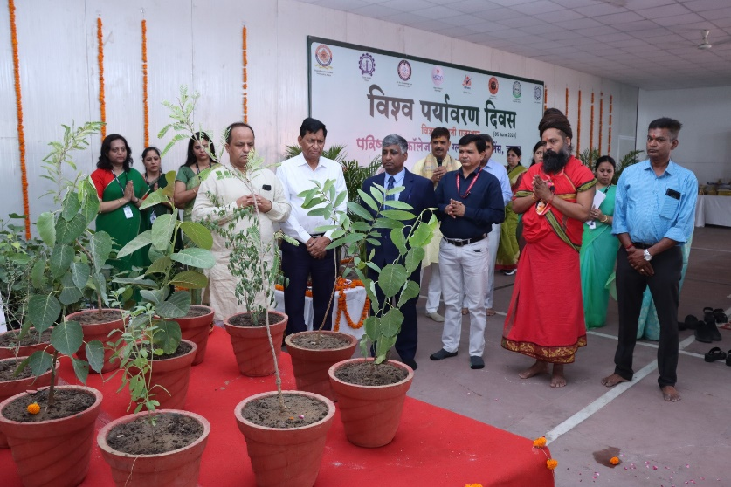
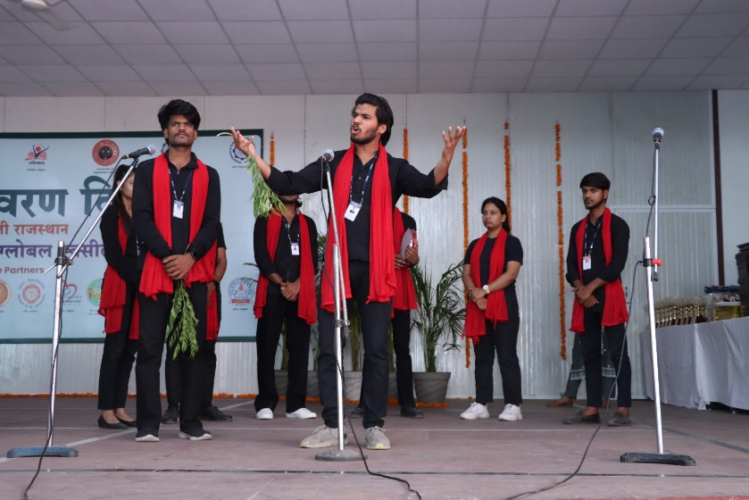
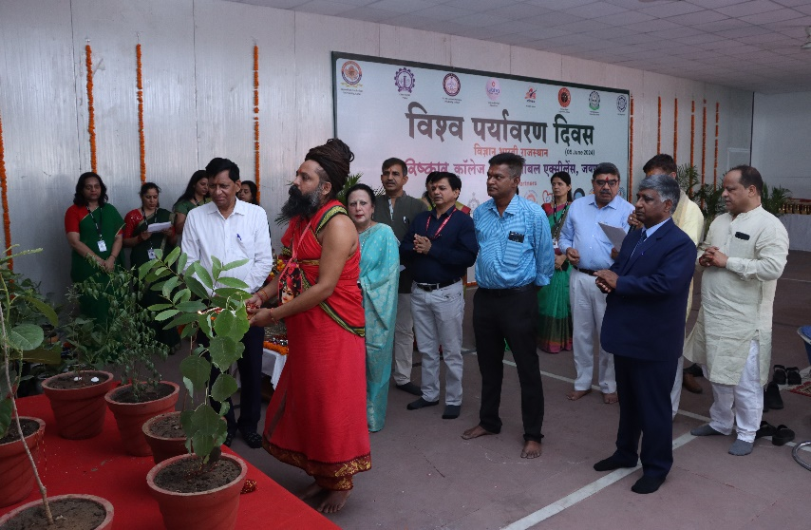
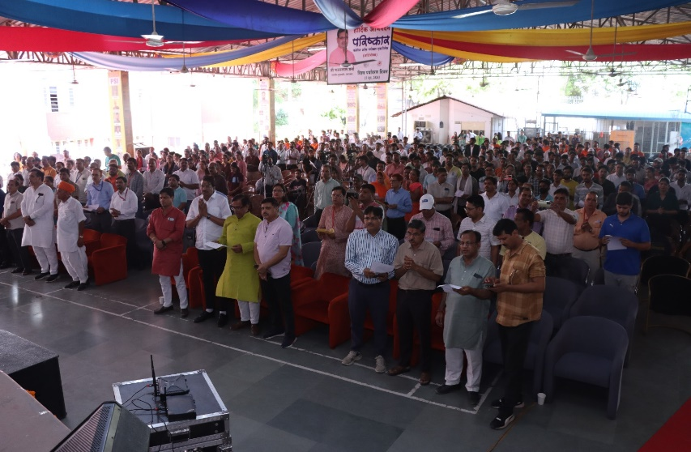
Vigyan Bharati Rajasthan

Newsletter April–September 2024

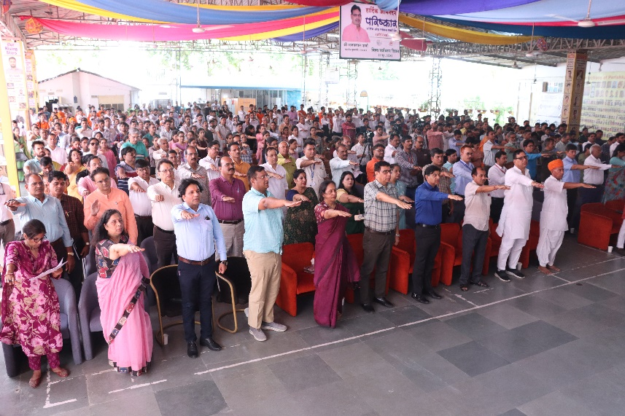
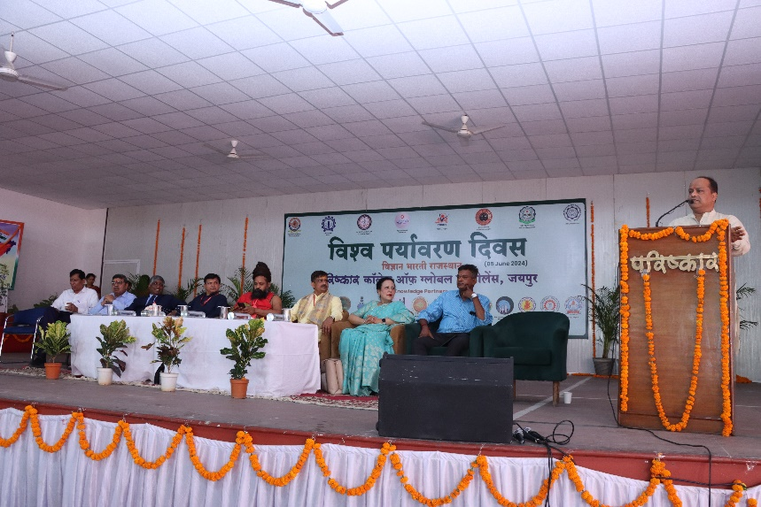
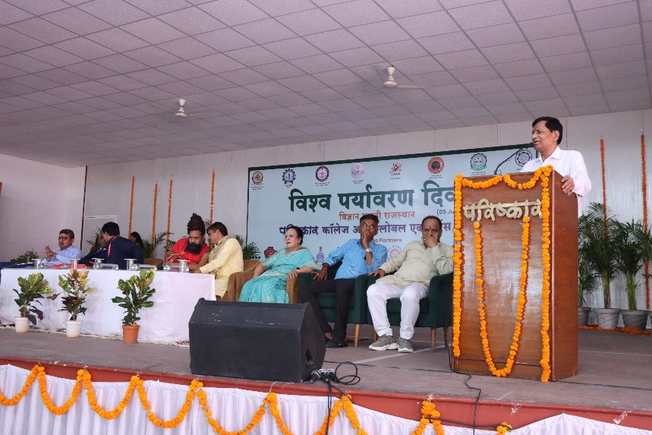
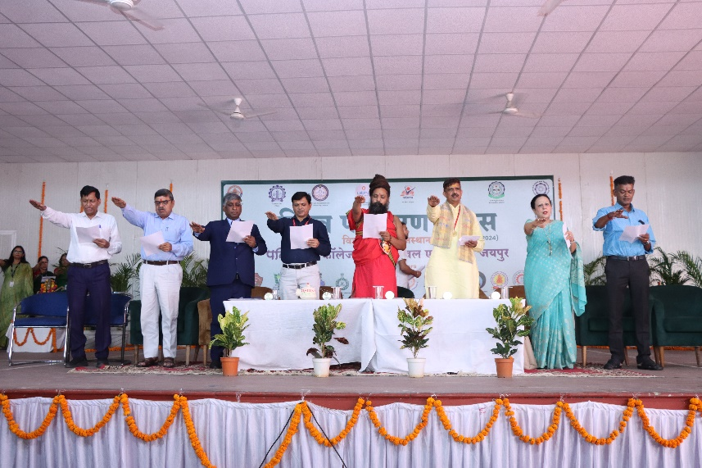
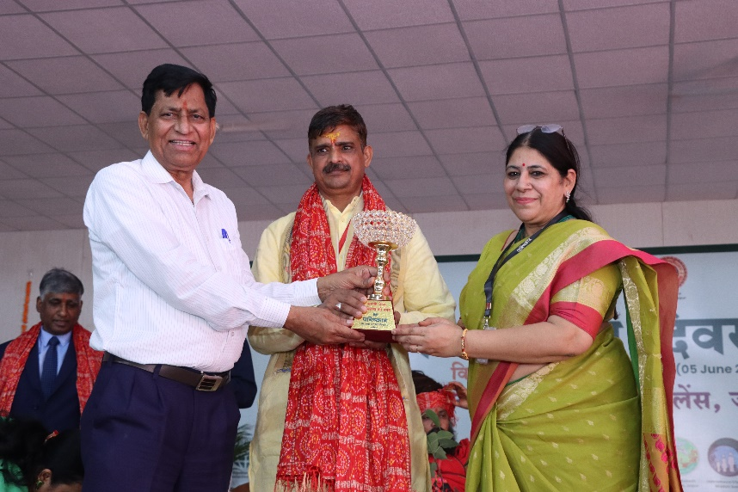
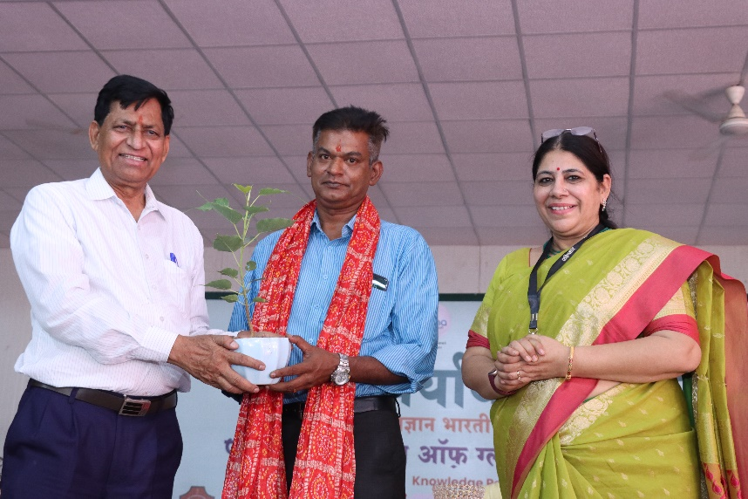
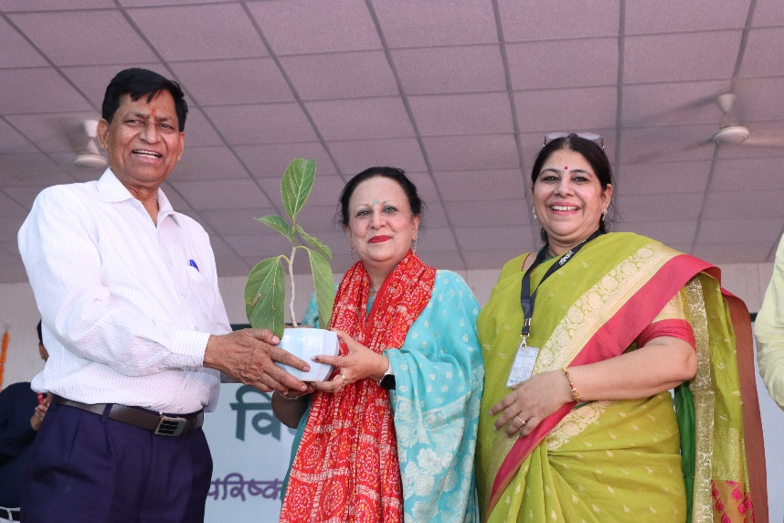
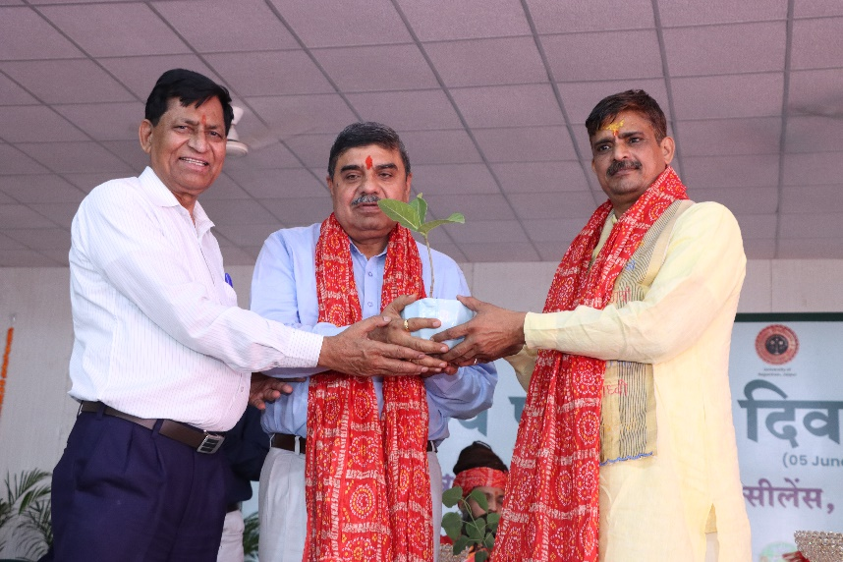
Newsletter April–September 2024

Vigyan Bharati Rajasthan

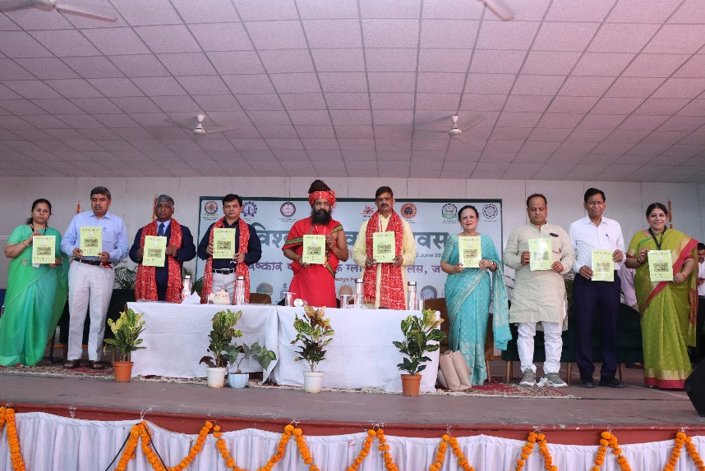
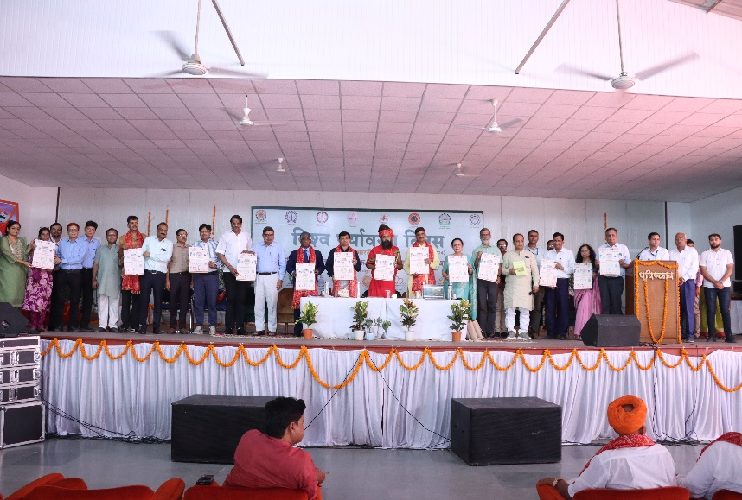
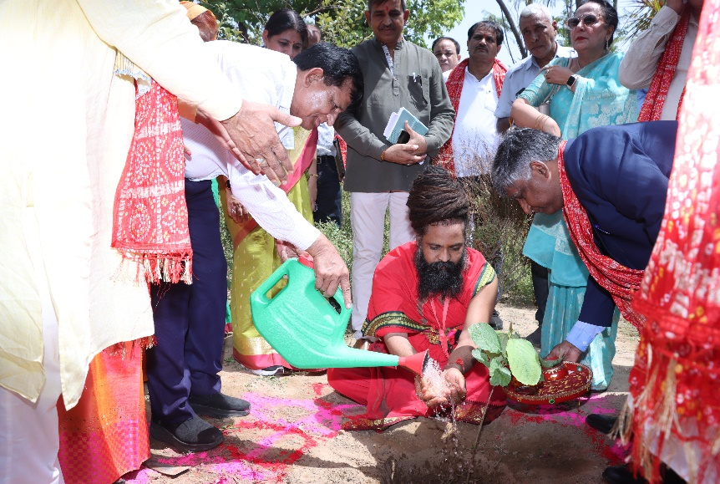
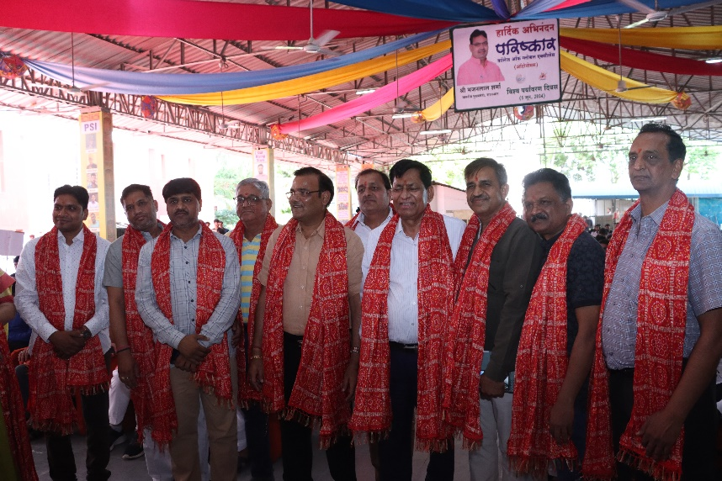
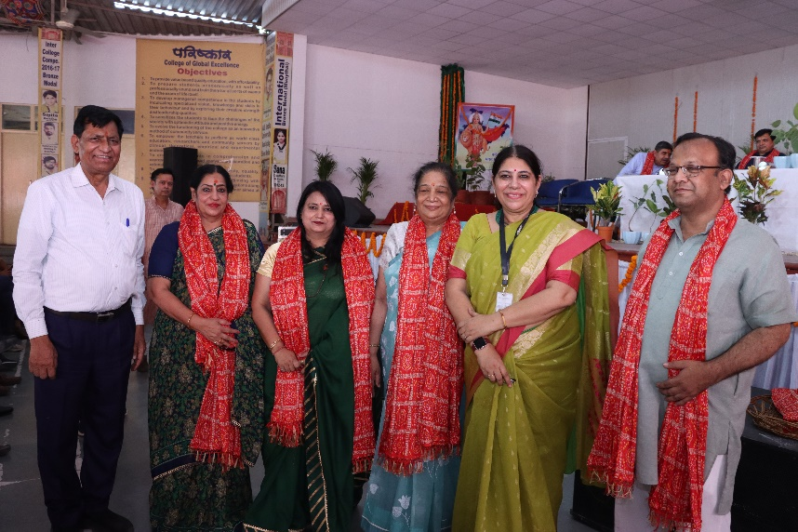
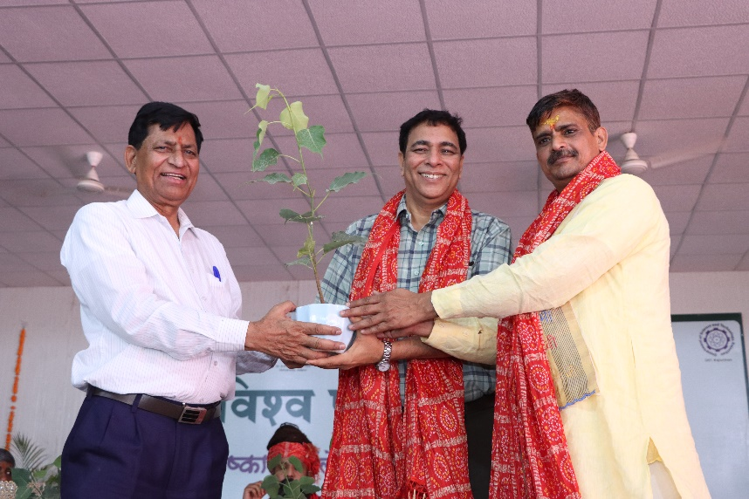
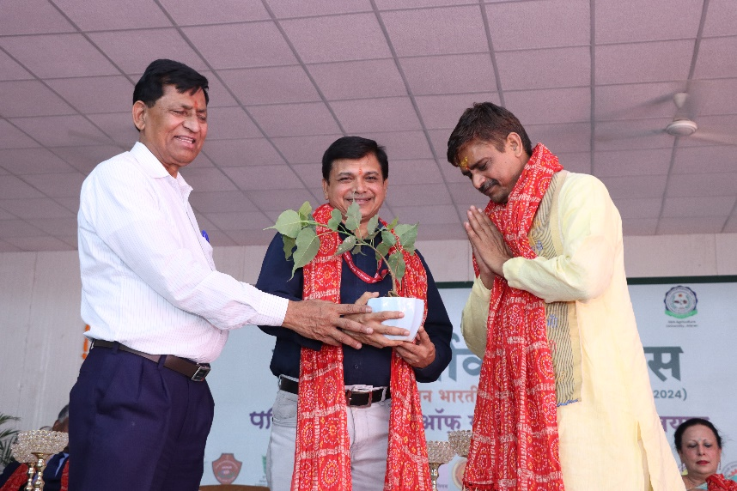
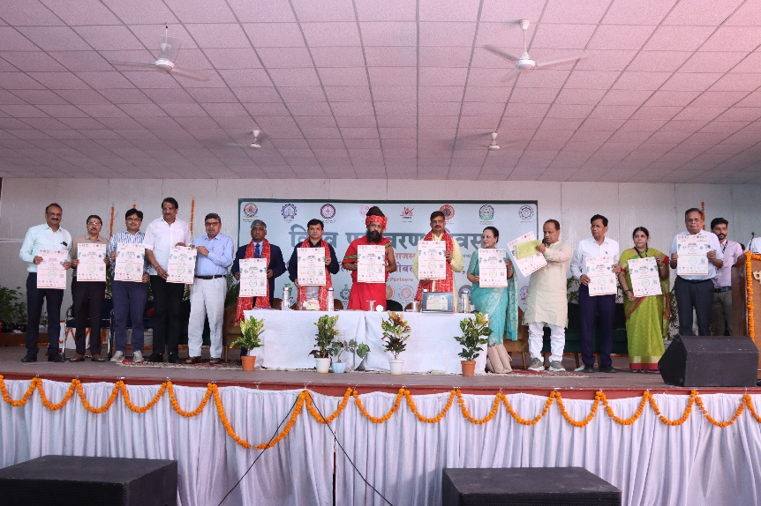
Newsletter April–September 2024

Vigyan Bharati Rajasthan

In the second half of the program, a national conference was also organized in which scientists and educationists from various institutions namely Dr. Sunil Chaturvedi (Director, Vibha Wari, Madhya Pradesh), Dr. Sumit Mishra (Senior Principal Scientist, CSIR-National Physical Laboratory, New Delhi), Prof. Balraj Singh, Prof. Nishtha Jaswal, Prof. Vishnu Sharma (Former Vice Chancellor, Rajasthan Veterinary and Animal Sciences University, Bikaner), Dr. P.C. Panchariya, Dr. Sudipti Arora (Assistant Director, Dr. B. Lal Institute of Biotechnology, Jaipur) and Dr. Atul Gupta (Founder and Chairman, Sunrise Organic) gave lectures on various topics related to the environment. At the end of the conference, a written recommendation was presented unanimously by all the speakers to the Central and State Government for environmental protection.
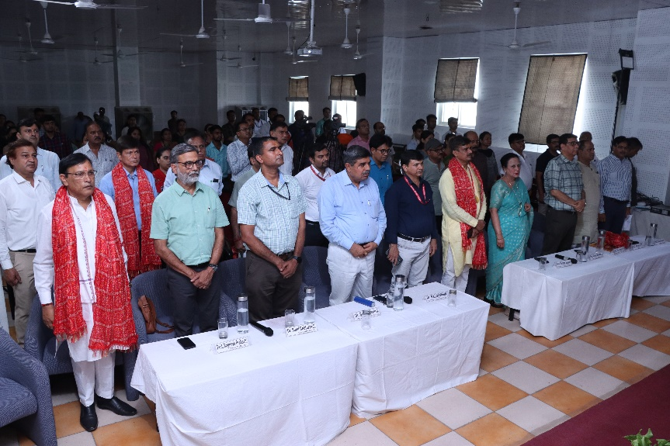
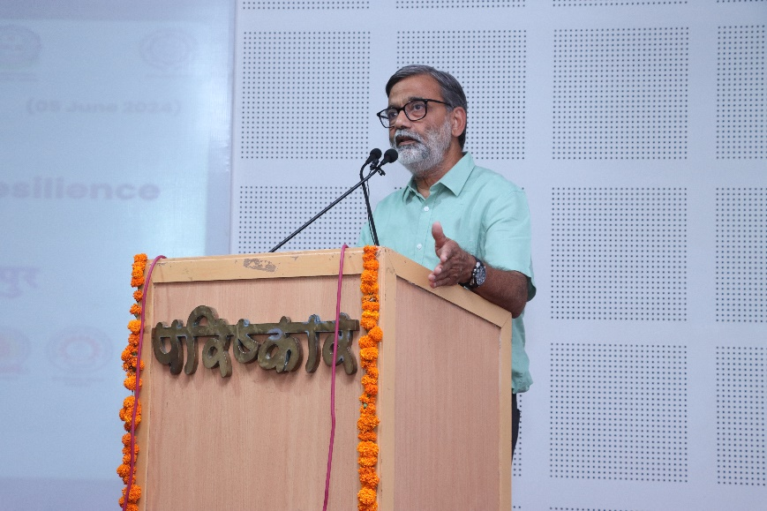
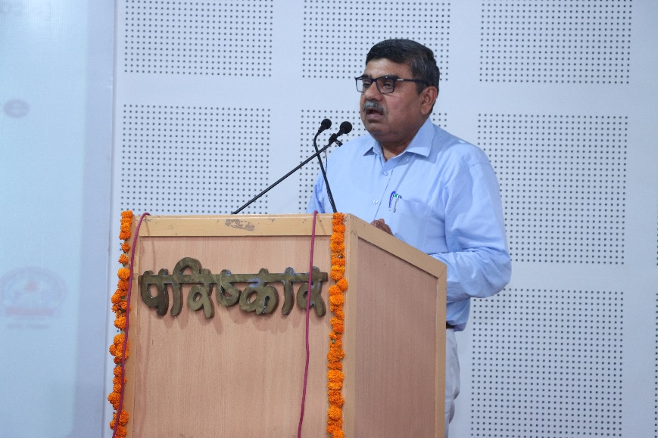
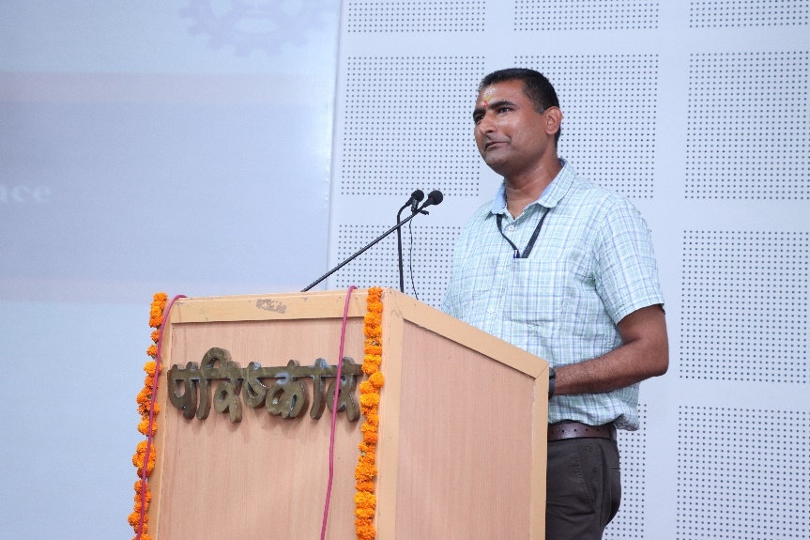
Vigyan Bharati Rajasthan

Newsletter April–June 2024

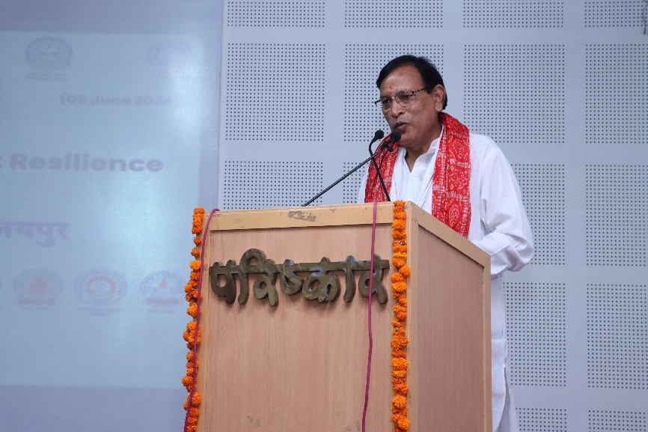
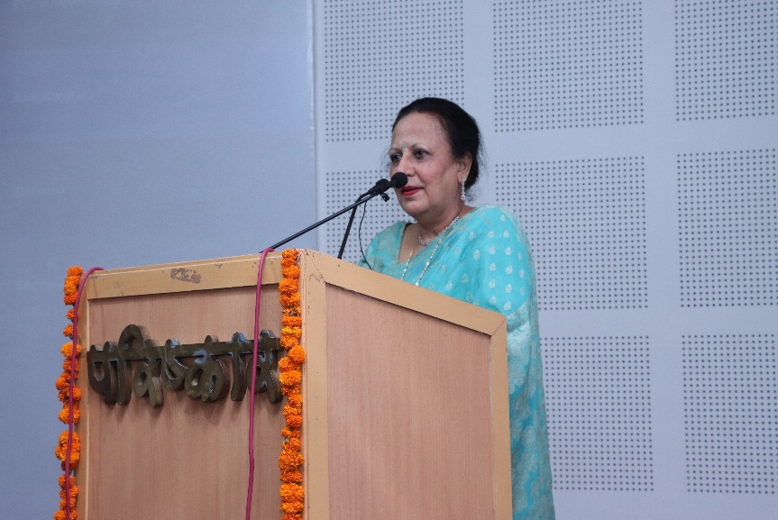
Vigyan Bharati Rajasthan

Newsletter April–September 2024

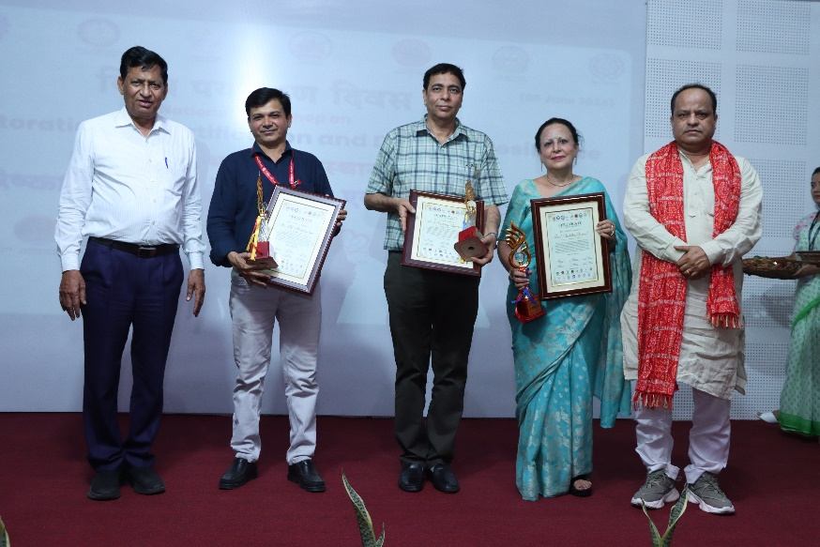
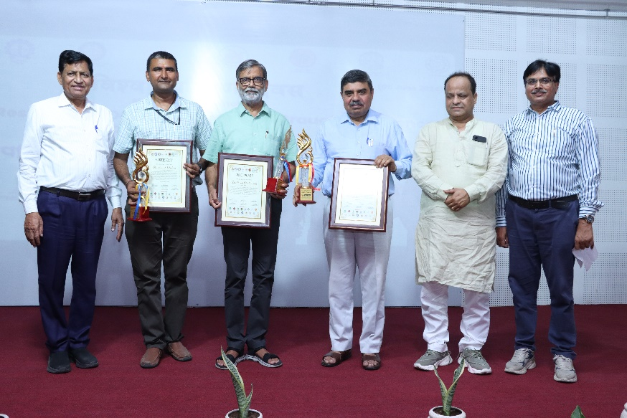
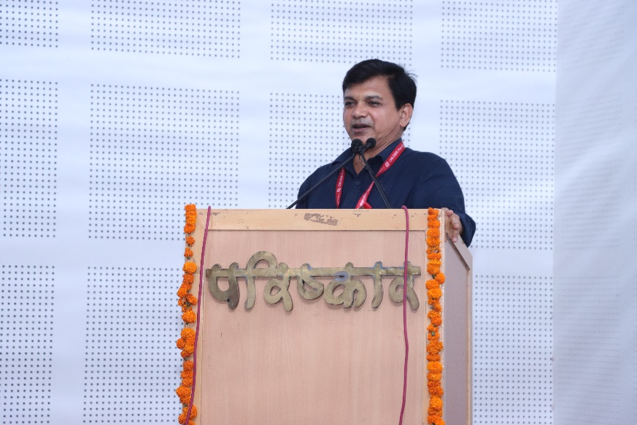
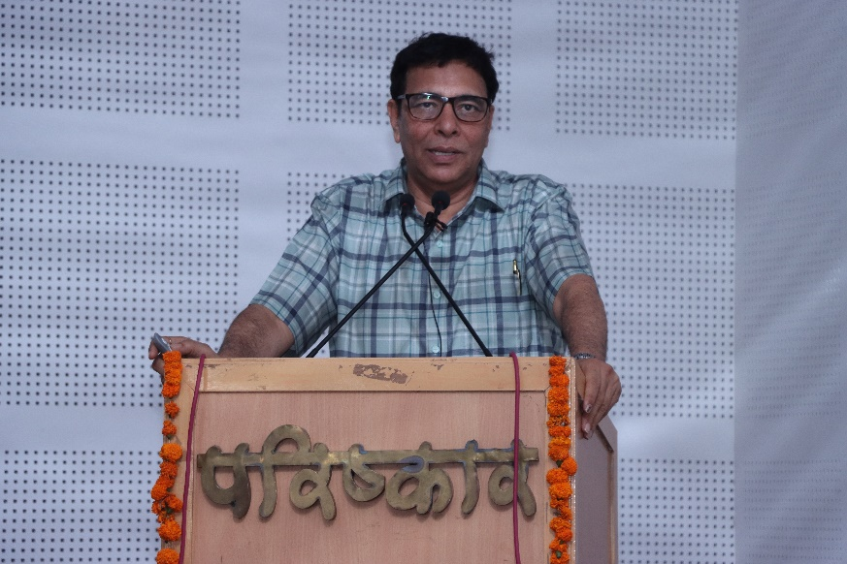
Newsletter April–September 2024

Vigyan Bharati Rajasthan

Newsletter April–September 2024

Vigyan Bharati Rajasthan

Newsletter April–September 2024

Vigyan Bharati Rajasthan

Newsletter April–September 2024

Vigyan Bharati Rajasthan

Newsletter April–September 2024

Vigyan Bharati Rajasthan

Newsletter April–September 2024

Vigyan Bharati Rajasthan

Newsletter April–September 2024

Vigyan Bharati Rajasthan

Newsletter April–September 2024

Vigyan Bharati Rajasthan

Newsletter April–September 2024

Vigyan Bharati Rajasthan

Newsletter April–September 2024

Vigyan Bharati Rajasthan

Newsletter April–September 2024

Vigyan Bharati Rajasthan

Newsletter April–June 2024

Vigyan Bharati Rajasthan

Newsletter April–June 2024

Vigyan Bharati Rajasthan

Vigyan Bharati Rajasthan

Newsletter April–June 2024

Newsletter April–June 2024

Vigyan Bharati Rajasthan

VIBHA Entities and Initiatives
S. No. | Programme | Name | Mobile | Email
1 | World Ayurveda Foundation (WAF) | Sh. Chandrasekhar Nair | 98809 45178 | chandra.wac2@gmail.com,
1 | World Ayurveda Foundation (WAF) | Sh. Ranjit Puranik | 98809 45178 | ranjit.puranik@gmail.com,
1 | World Ayurveda Foundation (WAF) | Sh. Pawan Godatwar | 98809 45178 | pgodatwar@gmail.com,
2 | International Institute of Waste Management (IIWM) | Ms. Beenesha P  Sh. Satish Wate | 94480 62878 | p.bineesha@iiwm.in,
 |  |  |  | satishwate@gmail.com
3 | Science India Forum (SIF) | Sh. T M Nandkumar  + 1/2 reprentatives from SIF | 73566 39522 | 39nandan39@gmail.com,
4 | National Ayurveda Students & Youth Association (NASYA) | Vd. Prashant Tiwari  + 1/2 representatives from NASYA  Chandramoli Yadaw | 82240 67777 | dr.prashanttiwari@gmail.com,
 |  |  |  | dr.cmyadaw@gmail.com
5 | SHAKTI | Ms. Leena Bavadekar | 98901 96273 | leenabavadekar@gmail.com,
5 | SHAKTI | Ms. Sudha Tiwari | 98901 96273 | sudha.gtiwari@gmail.com,
5 | SHAKTI | Ms. Bindu Suraj | 98901 96273 | b.bindupv@gmail.com,
6 | VIBHA VANI | Sh. N. P. Rajive | 90203 36500 | nprajive05@gmail.com,
6 | VIBHA VANI | Sh. Sunil Chaturvedi | 90203 36500 | sunil.vibhavari@gmail.com,
6 | VIBHA VANI | Dr. Bhalchandra G. Sathaye | 90203 36500 | bsathaye@gmail.com
7 | Global Indian Scientist and Technocrats Forum (GIST) | Dr. Yelloji Rao  Sh. Nandkumar Palkar |  | mirajkary@gmail.com, nkpalkar@gmail.com,
8 | Vidyarthi Vigyan Manthan (VVM) | Dr. Prashant Kodgire | 86026 42820 | pkodgire@gmail.com, dutt.mayuri@gmail.com,  bpandey@gmail.com,
8 | Vidyarthi Vigyan Manthan (VVM) | Dr. Mayuri Dutt | 86026 42820
8 | Vidyarthi Vigyan Manthan (VVM) | Dr. Brajesh Pande | 86026 42820
9 | India International Science Festival (IISF) | Dr. Arvind C Ranade | 98714 39594 | arvind.c.ranade@gmail.com,  rajeev@arsd.du.ac.in
9 | India International Science Festival (IISF) | Prof. Rajeev Singh | 98714 39594 | arvind.c.ranade@gmail.com,  rajeev@arsd.du.ac.in
10 | Science India | Sh. Debobrat Ghose | 99991 04134 | dghose@scienceindia.in,  sonamsingh@scienceindia.in,
10 | Science India | Ms. Sonam Singh | 99991 04134 | dghose@scienceindia.in,  sonamsingh@scienceindia.in,
11 | Bharatiya Vigyan Sammelan (BVS) | Dr. Vidyadhar Vaidya | 93762 06228 | vaidya.vidyadhar@gmail.com,  ruchir.in@gmail.com, jigneshborisagar05@gmail.com
11 | Bharatiya Vigyan Sammelan (BVS) | Dr. Ruchir Gupta | 93762 06228
11 | Bharatiya Vigyan Sammelan (BVS) | Shri Jignesh Borisagar | 93762 06228
12 | Vishw Ved Vigyan Sammelan (VVVS) | Sh. Kompella Sastry | 94403 28919 | kompellasastry16@gmail.com ,  ganti.murthy@iiti.ac.in
12 | Vishw Ved Vigyan Sammelan (VVVS) | Prof. Ganti Murthy | 94403 28919 | kompellasastry16@gmail.com ,  ganti.murthy@iiti.ac.in
13 | Tech 4 Seva | Prof. Vivek Kumar | 94126 19735 | vivekk@rdat.iitd.ac.in,  kotharianil67@gmail.com,
13 | Tech 4 Seva | Dr. Anil Kothari | 94126 19735 | vivekk@rdat.iitd.ac.in,  kotharianil67@gmail.com,
14 | Shiksha Shilpi | Dr. Ajay Mahajan | 94226 10555 | mahajay2013@gmai.com , pkkjoshi@gmail.com ,  jvjoshi2002@yahoo.co.in
14 | Shiksha Shilpi | Dr. P. K. Joshi | 94226 10555
14 | Shiksha Shilpi | Dr. Jayant Joshi | 94226 10555
15 | World Ocean Congress (WOSC) | Dr. Satheesh Shenoi | 94410 13377 | shenoi1958@gmail.com, tatasudhakar@gmail.com  prasanna.ocean@gmail.com
15 | World Ocean Congress (WOSC) | Sh. Tata Sudhakar | 94410 13377
15 | World Ocean Congress (WOSC) | Sh. Prasana Kumar | 94410 13377
16 | NEED | Sh. Abga R Babu | 98950 47772 | abga@vibhaindia.org, tripta_thakur@yahoo.co.in,  sumitkumarm@gmail.com,
16 | NEED | Dr. Tripta Thakur | 98950 47772
16 | NEED | Dr. Sumit Mishra | 98950 47772
17 | Mandala | Dr. Jajati Nayak | 94331 18008 | jajatimp@gmail.com,  manasi.malgaonkar@gmail.com,
17 | Mandala | Ms. Manasi Malgaonkar | 94331 18008 | jajatimp@gmail.com,  manasi.malgaonkar@gmail.com,
18 | Space on Wheel | Sh. Vivekananda Pai Sh. Akash Pandey  Sh. Naresh Chafekar | 98950 20301 | vpai2021@gmail.com, akashpandey.wb@gmail.com,  nchafekar@gmail.com,
19 | Vastukala (Architecture) | Sh. Kailasa Rao  Sh. Sanjay Bhandari Prof. V K Paul |  | kailashrao69@gmail.com, bhandarisanjay29@gmail.com, vk.paul@spa.ac.in
20 | Publication Division | Dr. Ruchir Gupta  Dr. Sumit Mishra | 94251 56958 | ruchir.in@gmail.com,  sumitkumarm@gmail.com

Newsletter April–June 2024

Vigyan Bharati Rajasthan

State Executive Committee

President
Dr. L.S. Rathore

Organizing secretary
Dr. Meghendra Sharma

Treasurer
Dr. Umesh Gupta

Vice President
Sh. S.N. Saini
Dr. Shankar Baboo

Joint secretary
Er. Shailesh Jain
Er. Sanjay Bansal

Executive members
Prof. N.K. Gupta, Director Education SKNU
Dr. Madhu Shrivastava, Ex. Principle Subodh Girls College
Dr. Amit Kotia, Assistant Professor RU
Mrs. Anju Singh, Central EC Member MSME
Dr. Santosh Sharma, Assistant Professor Govt. College Jaipur
Dr. Kavita Tak, Associate Professor Subodh PG College
Dr. Balram Tripathi, Associate Professor Subodh PG College
Er. Ashok Nagaich, Ex. Additional Chief Engineer, JVVNL
Er. Mahesh Paliwal, Ex. Director Engineering Doordarshan Kendra
Dr. Varun Jindal, Assistant Professor MNIT

Advisory Board

Dr. P.C. Panchariya, Director CSIR-CEERI, Pilani (Convenor)
Prof. B.R. Gurjar, Director NITTTR, Chandigarh
Prof. Ambarish S. Vidyarthi, VC BTU, Bikaner
Prof. S.K. Singh, VC RTU, Kota
Prof. Balraj Singh, VC SKNAU, Jobner
Prof. Sanjeev Sharma, VC NIA, Jaipur
Prof. N.P. Padhy, Director MNIT, Jaipur
Prof. Sandeep Sancheti, VC Marwadi University, Rajkot
Prof. K.K. Sharma, Ex VC MDSU, Ajmer
Dr. P.K. Rai, Director ICAR-DRMR, Bharatpur
Prof. Harish Hirani, Professor HAG IIT Delhi
Dr. B.L. Swami, Professor HAG MNIT, Jaipur
Dr. B. Lal Gupta, Director, BIBT, Jaipur
Dr. Raghav Prakash, Chairman PCGE, Jaipur
Er. Anurag Agarwal, Chairman ACEIT, Jaipur
Prof. K.B. Sharma, Principal Subodh PG College, Jaipur
Dr. Keshav Badaya, Chairperson St. Wilfred’s PG College, Jaipur
Prof. Ashwini Kumar, Ex. HOD RU
Dr. Ashwini Sharma, EX DG RajCOMP

Vigyan Bharati Rajasthan

Newsletter April–June 2024

Invited Members of Executive Committee

Vibhag Pramukh
Prof. Rishi Singhal, HoD Dept. of Physics, RU (Jaipur Vibhag Pramukh)
Prof. Bhawani Shankar, VC Lords University, Alwar (Alwar Vibhag Pramukh)
Dr. Pankaj Agrawal, Sr. Principal Scientist, CSIR-CEERI, Pilani (Jhunjhunu Vibhag Pramukh)
Dr. Brajraj Singh, Assistant Professor MUST, Laxmangarh (Sikar Vibhag Pramukh)
Sh. Jeevan Joshi, Academician (Churu Vibhag Pramukh)
Dr. Amit Shukla (Sawai Madhopur - Karauli Vibhag Pramukh)
Prof. Sudesh Kumar, Banasthali Vidyapeeth (Sanganer- Tonk Vibhag Pramukh)
Dr. Ashok Sharma, (Bharatpur Vibhag Pramukh)

Aayam Pramukh

- VVM
Dr. Madhu Shrivastava, Former Principal, S.S. Jain Subodh Girls College, Sanganer
Dr. Santosh Sharma, Assistant Professor, Shri Radha Govind Govt. College, Jaipur
Dr. Sumit Gupta, Professor, St. Wilfred’s College, Jaipur
Dr. Mayur Bhati, Project Officer, EIACP, ICAR-CAZRI, Jodhpur
Er. Ashutosh Sharma, CSIR-CEERI, Jaipur Campus

- NSOIM
Dr. Vijay Chatterjee, Sr. Scientist, CSIR-CEERI, Jaipur Campus
Adv. Chetan Meena, Entrepreneur
Sh. Pawan Pareek, CEO Chandra Group
Er. Satyendra Singh, Entrepreneur

- Shakti
Dr. Madhu Shrivastava, Former Principal, S.S. Jain Subodh Girls College, Sanganer
Dr. Kavita Tak, Associate Professor, S.S. Jain Subodh Girls College, Sanganer
Dr. Aparna Pareek, Assistant Professor, RU
Dr. Sunidhi Mishra, Assistant Professor, MUST, Laxmangarh
Ms. Neha Verma, Academic Head, MK Public School, Sikar

“सर्वस्य लोचनं शास्त्रं”
“विज्ञान (शास्त्र) सभी के लिए आँख के समान हैं”
“Science is an eye for everyone”

Contact Information

Office Address: 77/177, Arawali Marg, Shipra Path, Mansarover, Jaipur – 302020
Phone: 9829021975, 8058836972
E-mail: sec.vibharajasthan@gmail.com
Website: www.vibharajasthan.org
Newsletter April–June 2024

Vigyan Bharati Rajasthan

